Appendix F. News factor occurrence in the dataset
Figure F1. Occurrence of textual news factors in the dataset
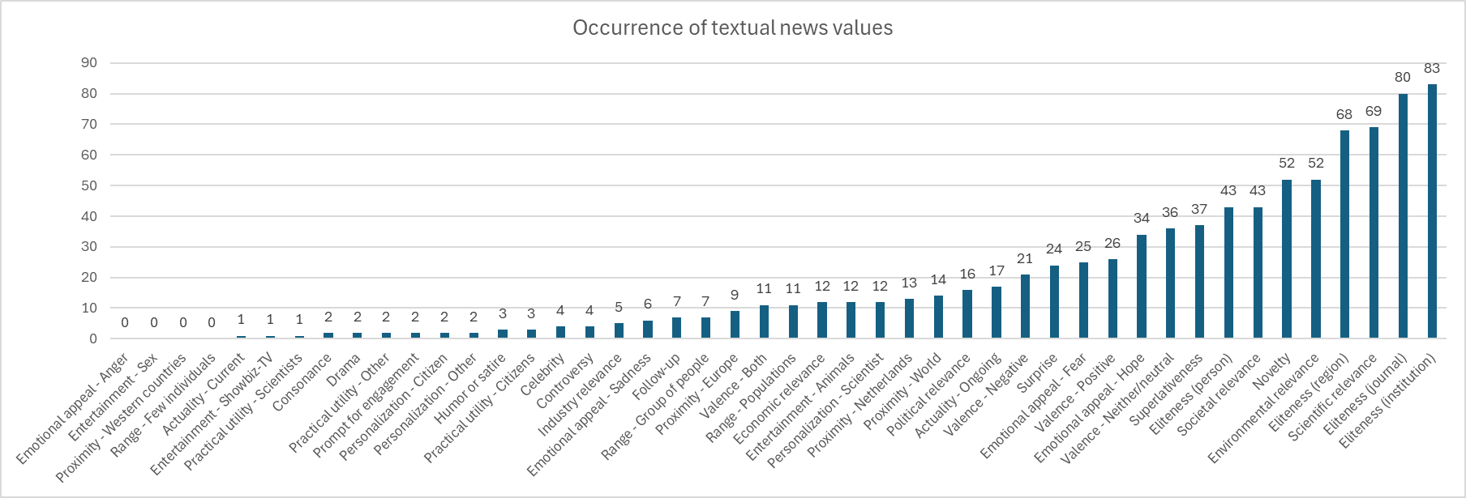
Figure F2. Occurrence of visual news factors in the dataset
