Evidence in the Service of Dissent: Strategic Communication of Science by German Corona-Protest Movements

Appendices
Appendix A. Identification of Scientifically Framed Discussions about COVID-19

Methods for Research Questions 1. To address research questions about the role of science in navigating the uncertainty caused by the pandemic in the communities of non-institutionalized political actors, we first identified Telegram posts about COVID-19 written from a scientific perspective. We focus on the content where the authors of Telegram channels discuss scientific aspects of the pandemic and ways to tackle this challenge. Identifying such posts involved several steps. First, we selected posts that contained COVID-related text patterns such as: “covid*,” “corona*,” and “sars-cov*.” The total number of posts after this step was reduced to 349,249. Second, we were searching for the following text pattern in the messages that indicate scientific reference: “research*”, “scientific*”, “science*”, “study*”, “professor*”, “doctor*”, “mRNA”, “spike*”, “mycoplasma”, “pathologists*”, “virologist*”, “basic immunity*”, etc. These words were derived after the close reading of Telegram posts. After the identification of central keywords like “scientific,” “hypothesis,” etc., the list was enlarged with the help of openthesaurus.de, i.e., a collaborative German-language dictionary. As an additional round to enlarge the scope of relevant keywords for Corona-related discussions with references to science and scientific terms, we prompted the ChatGPT-4o large language model asking to provide relevant words in German. These new words with a close meaning to the original anchor words were checked in the corpus of Telegram posts and subsequently added to the list for queries. 231,907 posts contained at least one of these science-related words. Third, we subset the intersection of Telegram posts which contain references both to COVID-19 and science (See Table A1 for the full set of keywords). Thus, the dataset was reduced to 126,389 posts.

Complete Dataset based on the list from Jost & Dogruel (2023)
Rows: 2,201,325
Time Frame: from 2016-09-09 to 2023-12-06
Pre-Processed Dataset
Rows: 1,402,461
Time Frame: from 2019-09-30 to 2023-12-06
Removed chats, only German language text, narrower time frame
Dataset for Structural Topic Modeling and Science- and COVID-related Analysis
Rows: 126,389
Time Frame: from 2019-09-30 to 2023-12-06
Keywords-based subsetting (Table A1)
Dataset for Sentiment Identification of Academic / Research Organization
Rows (sentences, not posts): 90,968
Dataset of Telegram Posts containing mentions of scientists from Leidecker-Sandmann et al. (2022)
Rows: 7630
Dataset of Telegram Posts containing mentions of academic articles
Rows: 870
Named Entity Recognition
Named Entity Recognition
URL extraction
Figure A1. Steps in data subsetting

Table A1.
Keywords to identify scientifically framed posts about COVID-19
Corona-related terms (terms and their variations referencing the pandemic)
"covid.*", "corona.*", "sars-cov.*", "covid-19.*", "corona-virus.*", "pandemie.*", "epidemie.*",
"ansteckung.*", "infektion.*", "quarantäne.*", "lockdown.*", "impf.*", "booster.*", "maskenpflicht.*",
"abstandsregel.*", "testpflicht.*", "pcr-test.*", "schnelltest.*", "inzidenz.*", "r-wert.*",
"virusvariant.*", "delta-variant.*", "omikron.*", "hospitalisierung.*", "intensivstation.*",
"virus.*", "gesundheitskrise.*", "sozialdistanz.*", "herdenimmunität.*", "viren.*", "isolationspflicht.*"
Science-related terms
"forschung.*", "wissenschaft.*", "wissenschaftlich.*", "studie.*", "professor.*", "doktor.*", "dr\\..*", "prof\\..*",
"[Mm][Rr][Nn][Aa]", "spike.*", "mykoplasmen", "patholog.*", "virolog.*", "immunität.*", "antikörper.*",
"statistik.*", "evidenz.*", "kontrollexperiment.*", "empiri.*", "akadem.*", "korrelation.*",
"modell.*", "hypothese.*", "metaanalyse.*", "review.*", "preprint.*", "befragung.*",
"fachmagazin.*", "fachjournal.*", "fachblatt.*", "fachartikel.*", "nobelpreisträger.*", "gentherapie.*",
"virusstruktur.*", "labor.*", "erforsch.*", "paper", "vortrag.*", "symposium.*", "epidemiolog.*",
"immunolog.*", "pathogen.*", "klinische studie.*", "randomisiert.*", "doppelblind.*", "peer-review.*",
"medizin.*", "biologie.*", "chemie.*", "physik.*", "biochemie.*", "zellkultur.*",
"\\b[Rr][Nn][Aa]\\b", "\\b[Dd][Nn][Aa]\\b", "protein.*", "enzym.*", "mutation.*", "varianten.*", "genetik.*", "replikation.*",
"transkription.*", "translation.*", "impfstoffentwicklung.*", "nebenwirkung.*", "placebo.*",
"infektiolog.*", "prävalenz.*", "letalität.*", "mortalität.*", "reproduktionszahl.*", "kontrollgruppe.*",
"intervention.*", "kohortenstudie.*", "pharmako.*", "dosierung.*", "wirksamkeit.*",
"wissenschaftler.*", "forscher.*", "laborant.*", "experiment.*", "analyse.*",
"signifikanz.*", "konfidenzintervall.*", "p-wert.*", "randomisierung.*", "\\bDaten.*", "[Dd]atensatz.*",
"aerosol.*", "partikel.*", "messtechnik.*", "Robert-Koch-Institut", "RKI", "Grippe.*", "Influenza.*",
"Autoimmun.*", "Gehirnhautentzündung.*", "autoimmune Enzephalitis.*", "CIPD.*", "Polyneuropathie.*", "Impfschaden.*",
"Hemiparese.*", "Neuropathie.*", "expert.*"

Table A2.
Performance metrics for the keyword-based detection of relevant Telegram posts against the Golden standard human assessment.
Category | Precision | Recall | F1 Score
0 | 1.00 | 0.96 | 0.98
1 | 0.91 | 1.00 | 0.95
Overall Accuracy |  | 0.97
Macro F1 Score |  | 0.96
Note. n = 100 posts, balanced groups (50 vs. 50)

The variety of terminology associated with science in our data requires clarification. Our study examines not only direct scientific content—such as posts describing results from recent studies—but also the broader discourse involving science-related perspectives on the pandemic. Vaccines, for example, are part of this wider discussion. Rather than focusing exclusively on purely scientific posts, we aim to detect and analyze the argumentative strategies used by corona-protesters when engaging with opposing viewpoints. In this context, terms like “science” or “research” may not be explicitly mentioned in the messages. Nevertheless, government measures to counter the pandemic—implemented in close cooperation with scientists, such as lockdowns, mask mandates, and vaccination campaigns—reflect an effort toward evidence-based policymaking. These measures indicate the influence of official science as an institution in decision-making processes. Moreover, we extensively validated the results of this approach to detect relevant posts (Grimmer et al., 2022, p. 30). First, we randomly selected 100 Telegram posts (a balanced sample of 50 posts in each category) which were annotated by a single human coder. Macro F1 score is equal to 0.96, and other metrics are presented in Table A2. Second, to gain an impression of the kinds of topics discussed in this subcorpus of science-related Telegram posts, we conducted Structural Topic Modeling (STM; Roberts, Stewart, & Tingley, 2019), using the date of publication and the type of Telegram channel (far-right, Querdenken, and conspiracists) as covariates. Figure 2 in the main text presents the most frequent topics in this subset, including vaccinations, COVID-related statistics, lockdowns, and more. In contrast, Figure A5, which represents the non-science-related subcorpus, lacks such focused scientific discourse and instead features a broader range of topics unrelated to COVID-19 science, such as politics, societal issues, and general public opinion. All technical details regarding the STM are provided below. Here, we simply note that this method was used as an additional validation step for the pre-selection of relevant Telegram posts about COVID-19 from a scientific perspective. We did not aim to analyze topic variation across different types of Telegram channels in our sample, as such a granular approach is beyond the scope of this study. However, it is worth noting that the results of the STM were validated using word and topic intrusion tests, which demonstrated satisfactory outcomes.
Structural Topic modeling. In this study, we employ Structural Topic Modeling (STM) as outlined by Roberts, Stewart, and Tingley (2019) to identify the predominant themes within science-related posts on Telegram. This text-as-data approach facilitates the incorporation of control variables, enabling the estimation of both topical content and prevalence. The application of STM necessitates several text preprocessing steps, including tokenization, conversion to lowercase, and the removal of punctuation, stopwords, special characters, emojis, and numerical values. Subsequently, all tokens are lemmatized to their base forms using the SpaCy algorithm (Honnibal & Montani, 2017). We excluded words that appeared in fewer than one document by setting the lower.thresh parameter in the prepDocuments function of the STM package, while refraining from imposing an upper threshold due to the extensive list of stopwords (n = 620). Given our computational resources, we analyzed the entire corpus of available Telegram posts without sampling.
A significant challenge in topic modeling is determining the optimal number of topics (k-value) to ensure that the resulting topics are both semantically meaningful and distinct from one another. To address this, we adopted an iterative methodology inspired by Bossetta, Segesten, and Bonacci (2023) and supported by recommendations from Roberts et al. (2019) and Yarchi, Baden, and Kligler-Vilenchik (2021). Utilizing the searchK function from the STM package, we generated a series of models evaluated based on diagnostic parameters, particularly focusing on the balance between semantic coherence and exclusivity. Semantic coherence assesses the co-occurrence frequency of the most representative words within a topic, while exclusivity measures the uniqueness of words to a specific topic as opposed to their distribution across multiple topics. These metrics are crucial for developing a topic model with interpretable and clearly delineated topics.
To determine the optimal k-value, we initially explored a range from 10 to 100 in increments of 10 (Figure A2). This range was subsequently refined to between 15 and 35, with a step size of 2 (Figure A3), and further narrowed to 20–30 (Figure A4). Through this iterative process, we identified that a k-value of 25 offers the most favorable balance between semantic coherence and exclusivity, thereby providing a robust and interpretable topic structure for our analysis (Figure 2 in the main text).
To determine an appropriate number of topics for the STM applied to the corpus of Telegram posts lacking specific keywords, we initially fitted a model with K=0 using spectral initialization. This baseline model corresponds to the algorithm proposed by Mimno and Lee (2014) and allowed us to explore the data structure without predefining the number of topics. Using the labelTopics function from the STM R package, we assessed the coherence and interpretability of the emerging topics in the preliminary model. The STM developers emphasize that this procedure has no particular statistical guarantees and should not be regarded as estimating the “true” number of topics. However, it is a useful starting point and offers the computational advantage of requiring only a single run (Roberts et al., 2019, p. 13). Unlike the science-related subcorpus, we chose not to perform multiple iterations of this procedure, as the topic modeling served solely as an additional test to evaluate the effectiveness of the keyword-based selection of relevant posts. Therefore, Figure A5 presents 51 topics derived from this algorithm.
Word and Topic intrusion tests. To validate the results of structural topic modeling on the science-related subcorpus of Telegram posts, we conducted word and topic intrusion tests (Chang et al., 2009) with the use of the oolong package in R (Chan & Sältzer, 2020). Both the word intrusion and topic intrusion tests assess the coherence and distinctiveness of the STM model’s outputs by having raters identify anomalies. In the word intrusion test, raters are given a set of words from a specific topic along with one irrelevant word and must pinpoint the intruder, evaluating the relevance of the topic's vocabulary. In the topic intrusion test, raters review a collection of topics associated with a document and identify the topic that does not belong, thereby assessing the model’s ability to generate distinct and coherent topics.
The STM demonstrates promising performance in the word intrusion test, achieving a mean precision of 0.72 with statistically significant results (p < 0.001), which suggests a robust ability to identify relevant words. In the topic intrusion test, the mean topic log odds (TLO) of –2.28 did not reach statistical significance (p = 0.1133), indicating that distinguishing irrelevant topics may be more challenging. This outcome is expected given our objective to extract a science-related subcorpus using an extensive list of keywords. Additionally, Krippendorff’s alpha of 0.222 reflects some variability in rater agreement, highlighting areas where evaluation consistency could be further enhanced. However, for our purposes of using the STM as an additional validation check for keyword-assisted selection of the text subcorpus, these results are sufficient.

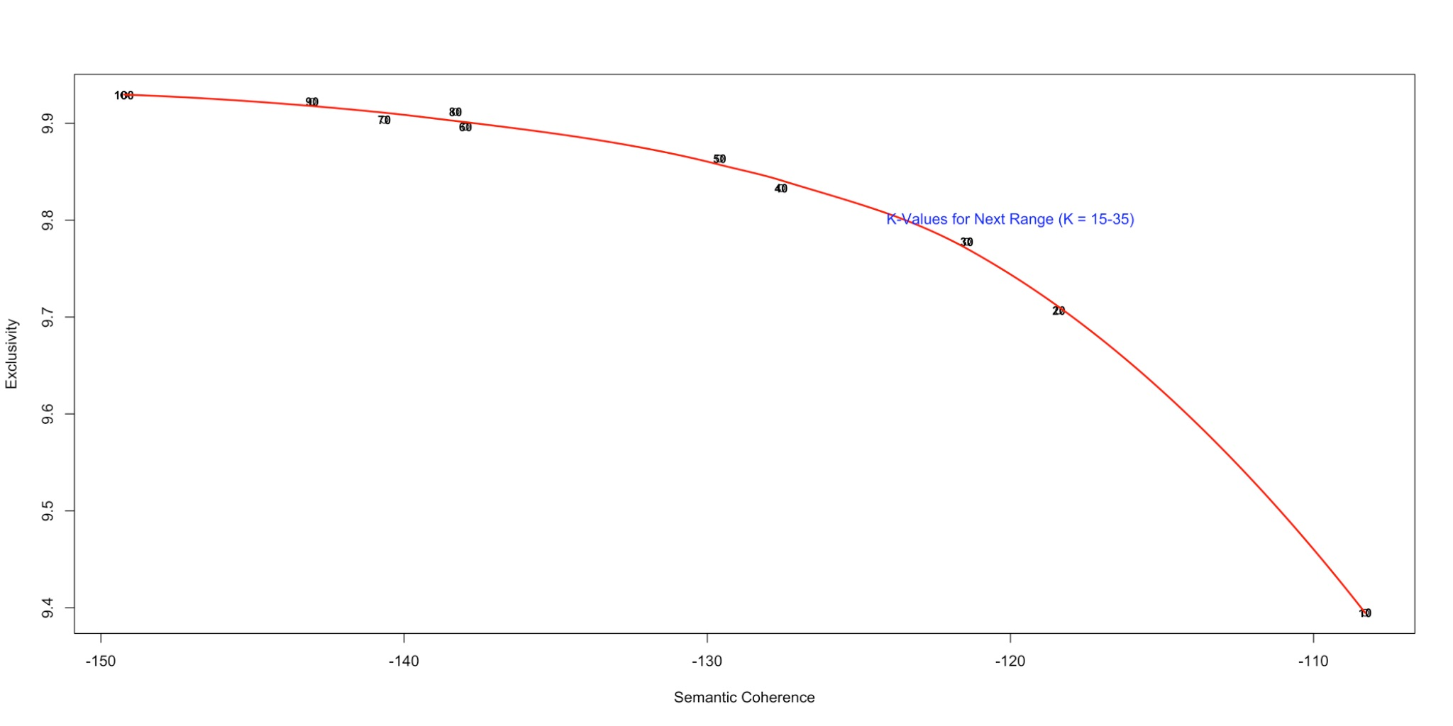
Figure A2. SearchK Topic Comparison for Broad Range of 15-35 Topics with interval = 2, Science-related Telegram posts

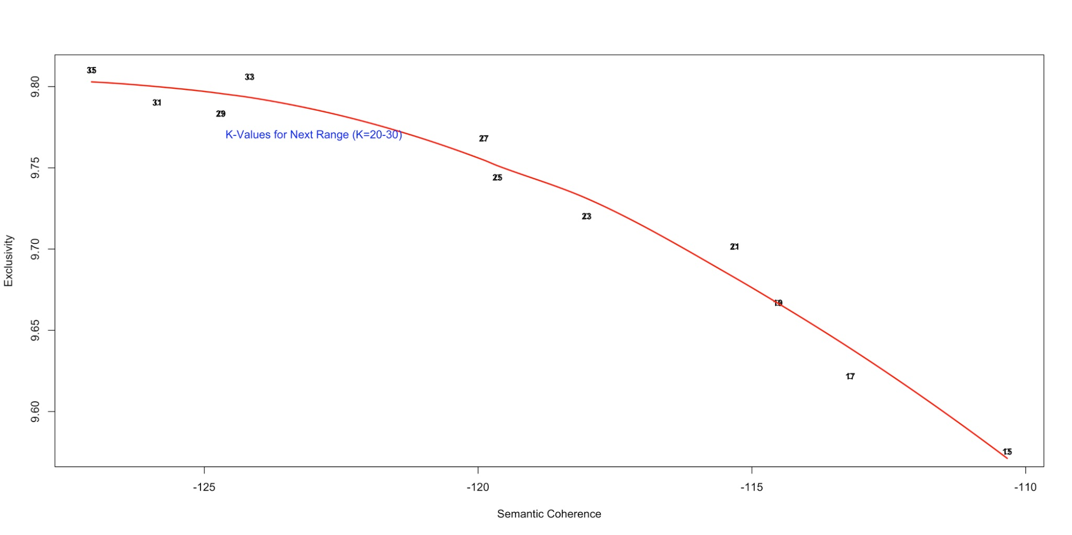
Figure A3. SearchK Topic Comparison for Broad Range of 20-30 Topics with interval = 1, Science-related Telegram posts

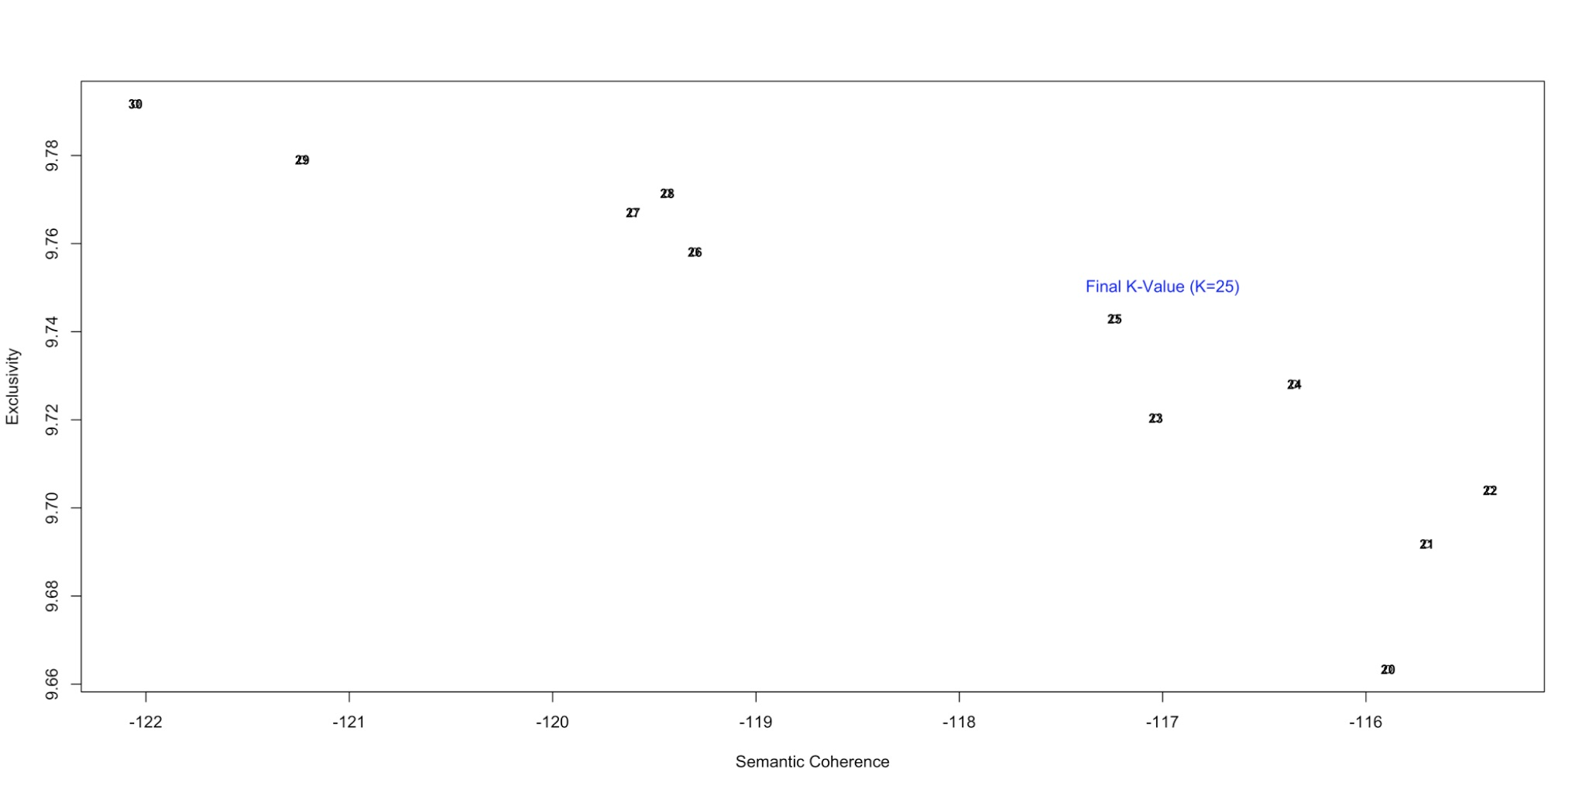
Figure A4. SearchK Topic Comparison for Broad Range of 20-30 Topics with interval = 1, Science-related Telegram posts

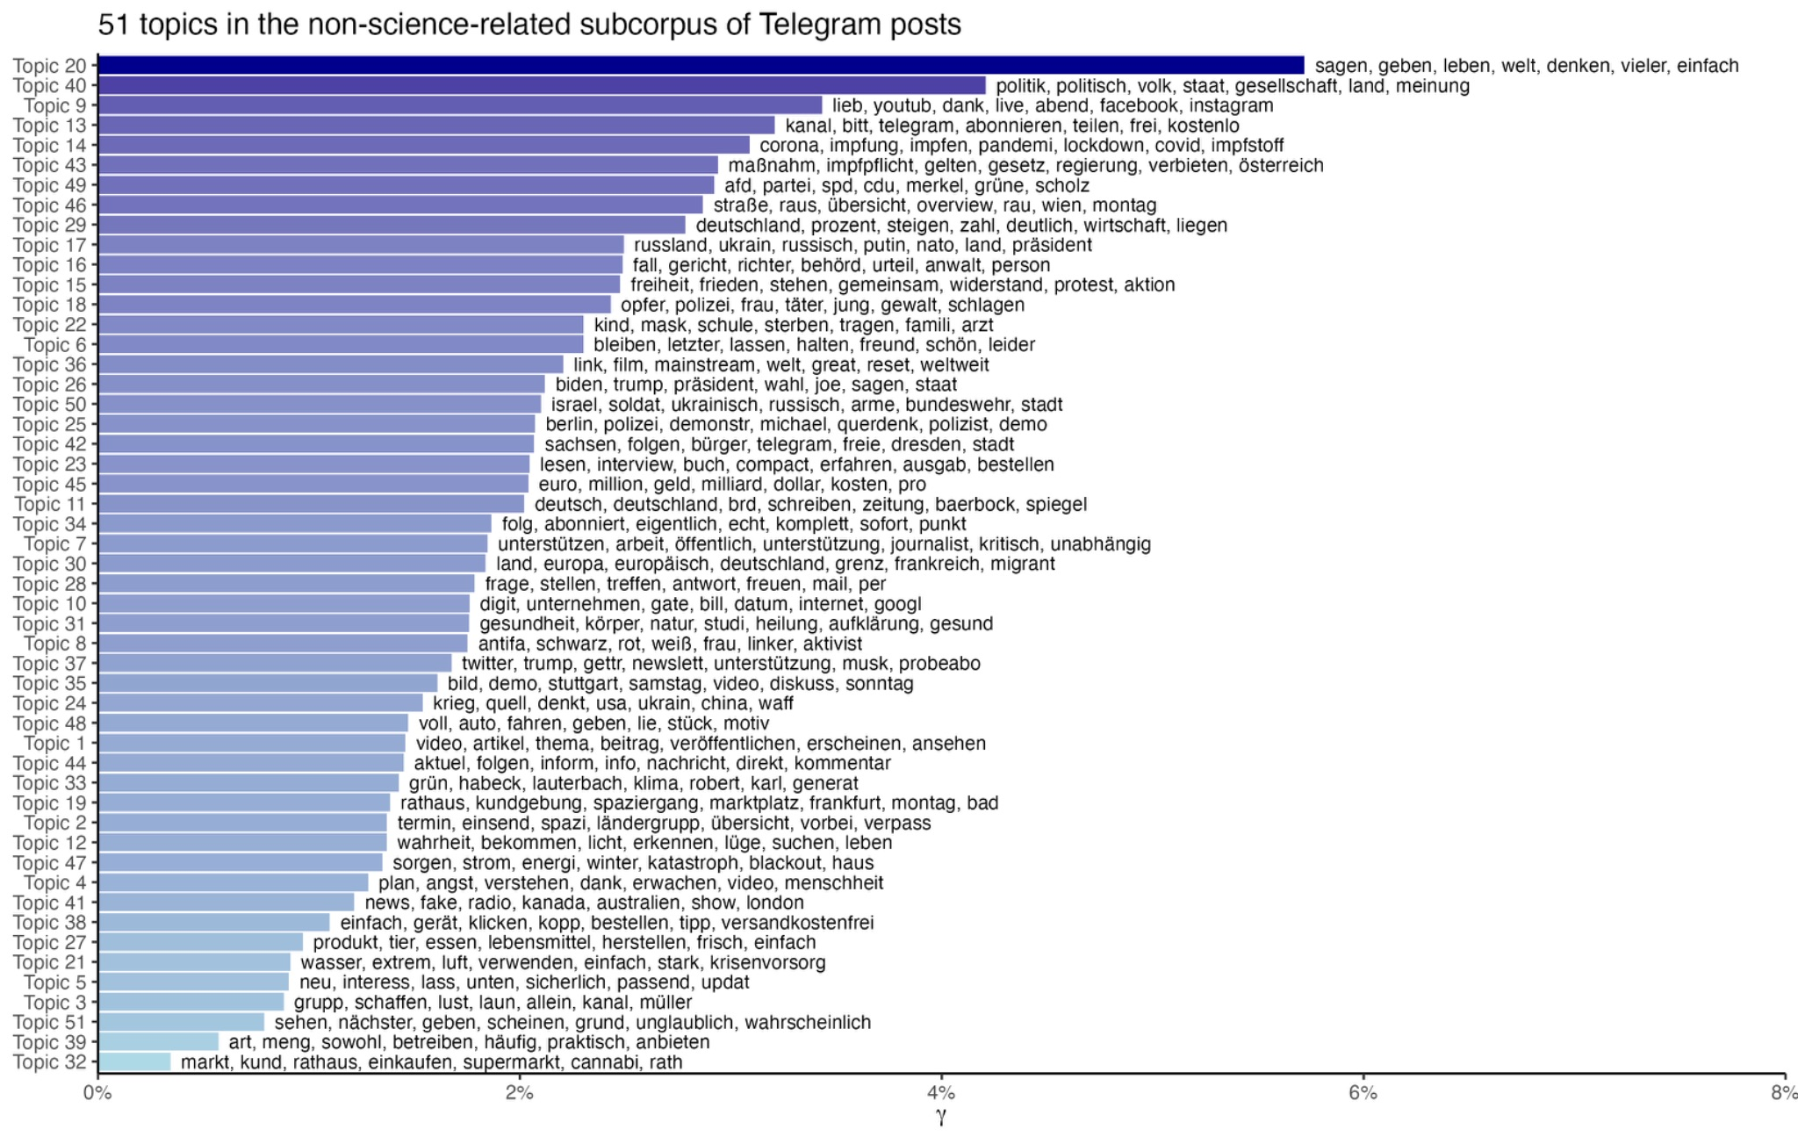
Figure A5. Topics in Telegram posts that do not contain keywords referring to the science-related discussions about COVID-19
Research Question 1, Additional Information. After identifying the science-related Telegram posts, we compute the daily share of Telegram posts about COVID-19 written from a scientific perspective and use this metric as dependent variables in the formula below:

$$Share of science-related posts{}_{i} = β{}_{0}+β{}_{1}* COVID Cases +β{}_{2}*Share of science posts{}_{i-1} + X{}_{2}*Controls{}_{i,j}+ β{}_{3}*week{}_{t} + u{}_{i}$$
Formula 1

where i defines the day when a Telegram post was published, t the week of publication, and j the month. We employ a multilevel regression framework (Gelman, 2007), wherein day-level parameters represent Level 1 and are nested within weeks or months. Regarding the factors included in the model, we first examine the association between the daily share of science-related posts and the daily number of COVID-19 cases.
There are several reasons for the growing interest in the dynamics of COVID-19 cases. First, statistics on COVID-19 infections were the most visible indicator during the pandemic, on par with the data on coronavirus-related death cases (Kubiczek & Hadasik, 2021). These data were featured in mainstream news media, government press releases, and public health dashboards. Because of their routine dissemination, these numbers became a central reference point for the public when assessing the current situation. In other words, many individuals came to gauge “how bad things are” based on these figures. Second, rising COVID-19 cases often preceded heightened restrictions and strained healthcare systems (Thompson, 2020). The higher the case count, the more uncertain individuals felt about their safety, the stability of societal functions (e.g., schooling, work, supply chains), and the feasibility of planning ahead (Holman et al., 2020). Third, throughout the pandemic, public health agencies, policymakers, and researchers relied heavily on case numbers as a key indicator of the pandemic’s severity. For instance, the Robert Koch Institute, Germany’s national public health institute, regularly published detailed situation reports during the pandemic. The Johns Hopkins Coronavirus Resource Center became a global reference during the pandemic and provided real-time case tracking to inform public policy. Finally, societal uncertainty is not static; it fluctuates as conditions evolve. Daily case counts provide a dynamic, time-sensitive measure that changes regularly. This allows researchers to link day-to-day variation in perceived uncertainty to corresponding changes in protesters’ discourse. For instance, on days when cases spike, individuals may be more motivated to seek out or reference scientific rationale, possibly in an attempt to make sense of what is happening. We control the lagged share of science-related posts, tthe lagged number of COVID-19 related deaths, i.e., data collected by the official agency of the EU, European Centre for Disease Prevention and Control.
The degree of uncertainty was included in the model in some of the robustness checks. This variable is understood as incomplete knowledge about the world and the connections between current actions and future outcomes and measured by the World Uncertainty Index (Ahir et al., 2018), which provides a number of country-level indicators at different levels of granularity (quarterly or monthly data). Methodologically, the essence of this approach is based on text mining of the Economist Intelligence Unit (EIU) country reports. A country report typically encompasses an array of economic and political factors, including domestic economic conditions, foreign and trade payments, and the overall impact of these variables on the country’s risk profile. More details about the assembly of reports are provided in the original paper by Ahir et al. (2018). Then, in order to construct the World Uncertainty Index, the authors count the number of times that uncertainty is mentioned in the EIU country reports. To do this, it is first necessary to search through each country and quarter/month report for the words “uncertain”, “uncertainty”, and “uncertainties”. Next, the indices are normalized by the total number of words and rescaled by multiplying by 1,000. A higher number indicates a greater degree of uncertainty, and vice versa. The main advantage of the uncertainty index is its standardization and focus on a wide range of social challenges (a separate index exists, for example, for pandemic uncertainty). However, the downside of these data is their granularity.
The effect of the degree of uncertainty on the references to science in the communities of corona-protesters can also be correlated by the overall social and economic situation in Germany during the period under scrutiny. Therefore, we also include in the model the monthly level of unemployment in the West and East German regions (separately included in the model) and for the monthly inflation rate compared to the previous month.

Table A3.
Multilevel Regression Model Estimates
Variable | Model 1  (Logged Predictors) | Model 2  (Non-Lagged Cases/Deaths) | Model 3  (Uncertainty Groups) | Model 4  (Economic Controls)
Intercept | 0.046 (0.008)*** | 0.099 (0.003)*** | 0.035 (0.005)*** | 0.066 (0.007)***
Lagged Cases | 0.005 (0.001)*** | - | - | -
Lagged Deaths | 0.003 (0.002) | - | - | -
Cases (std., same day) | - | 0.007 (0.002)*** | - | -
Deaths (std., same day) | - | 0.004 (0.002)* | - | -
Lagged Cases (std.) | - | - | 0.003 (0.001)** | 0.004 (0.002)*
Lagged Deaths (std.) | - | - | –0.002 (0.001) | –0.001 (0.002)
Lagged Share of Science | - | - | 0.645 (0.028)*** | 0.379 (0.034)***
Uncertainty (continuous, std.) | - | - | - | –0.019 (0.022)
Inflation (prev. month, std.) | - | - | - | –0.001 (0.003)
Long-term Unemployment (West, std.) | - | - | - | –0.027 (0.036)
Long-term Unemployment (East, std.) | - | - | - | 0.038 (0.036)
Random Intercept | Week | Week | Uncertainty Group | Month-Year
Observations | 764 | 764 | 764 | 764
Groups (Week/Month-Year) | 110 | 110 | 3 | 26
Residual SD | 0.020 | 0.020 | 0.024 | 0.022
Week/Month-Year Intercept SD | 0.023 | 0.029 | 0.007 | 0.012
REML | -3493.4 | -3464.7 | -3459.5 | -3515.1
Note: This table shows the association of different variables with the production of science-related posts in the communities of corona-protesters.
*** p < .001, ** p < .01, * p < .05

Appendix B. Sentiment Change Overtime
Methods for Research Question 2. To address the research question about the overtime variation in the sentiment towards science in the communities of corona-protesters, we exploit the following model:

$$Science Sentiment{}_{i} = β{}_{0}+β{}_{1}* Trend{}_{i}+β{}_{2}* Trend{{2_{i}}^{}}_{}+β{}_{3}* cases_{i-1}+β{}_{4}* deaths_{i-1} + u{}_{i}$$
Formula 2

where i defines the day when a Telegram post was published. We focus on the period from the end of January, 2020 till the end of February, 2022. The ScienceSentiment variable indicates the sentiment towards science in the communities of corona-protesters. To identify sentiment in Telegram posts, we utilized the German Sentiment BERT model proposed by Guhr et al. (2020). The automatic classification process faced challenges due to the heterogeneous length of the analyzed Telegram posts. Cohen’s Kappa (0.346) and Krippendorff’s Alpha (0.296) indicate fair but not strong agreement among human validators. This suggests some level of consistency, but substantial disagreement persists, highlighting the need for clearer annotation criteria. This situation happened because some posts contained sentences exhibiting both positive and negative or neutral sentiments, complicating the labeling process for human validators. A third human annotator resolved disagreements in sentiment estimation. These assessments were then compared to the BERT classifications. The model’s F1-Macro is 0.64 (Table B1). Despite this moderate metric score, employing the model’s labels aligns with our research objectives. From a theoretical perspective, identifying positive sentiment is our primary focus. A conservative approach—prioritizing precise detection of genuinely positive messages over the risk of overestimating sentiment—is preferable. Accordingly, the model achieves a precision of 1.0 for positive sentiment in Telegram posts, while recall is 0.55. This conservative bias ensures that the model’s positive classifications align with our analytical and theoretical requirements.

Table B1.
Performance metrics for the sentiment categorization by German BERT model (Guhr et al., 2020) of Telegram posts against the Golden standard human assessment
Category | Precision | Recall | F1 Score
Positive | 0.54 | 0.62 | 0.57
Negative | 1.00 | 0.55 | 0.71
Neutral | 0.56 | 0.75 | 0.65
Overall Accuracy |  | 0.64
Macro F1 Score |  | 0.64
Note. n = 180 posts, balanced groups

Trend: This variable represents a time trend, indicating the progression of time. It is included to capture any linear trend in sentiment over time. ${Trend}^{2}$: This is a quadratic term of the trend variable, which is included to capture potential non-linear trends in sentiment over time.
$cases_{i-1}$: This variable represents the number of COVID-19 cases from the previous day. It is included to measure the impact of the reported number of cases on current sentiment.
$deaths_{i-1}:$This variable represents the number of COVID-19-related deaths from a previous day. Similar to lagged_cases, it aims to capture the delayed effect of past deaths on current sentiment.
Science, Scientists, and Research Institutions as a Target of Corona-Protesters. As part of an exploratory analysis, we decided to assess the sentiment towards (1) scientists, (2) academic and research institutions, and (3) scientific publications. We used Named Entity Recognition (Akbik et al., 2019) to detect scientists and official institutions discussed by the channels. We employed the list of academic researchers specializing in virology and epidemiology from Leidecker-Sandmann et al. (2022), which included 1,200 names of scientists. Next, from the organizational entities, we extracted universities, institutes, and tertiary education institutions (“Hochschule” in German). From the corpus of science-related Telegram posts, we also extracted links to online sources and identified science-related domains (i.e., websites of academic journals and repositories for archiving preprints). An overview of the domains classified is provided in Table B2.

Table B2.
Overview of science-related web-domains in the subcorpus of COVID-related Telegram messages
Domain | Count of Telegram Messages
ncbi.nlm | 337
nature.com | 129
medrxiv.org | 93
thelancet.com | 70
mdpi.com | 59
clinicaltrials.gov | 48
doi.org | 44
researchgate.net | 44
nejm.org | 42
onlinelibrary.wiley.com | 38
bmj.com | 30
sciencedirect.com | 26
link.springer.com | 23
papers.ssrn.com | 19
academic.oup.com | 18
biorxiv.org | 17

Subsequently, we applied the BERT model for sentiment extraction in German (Guhr, Schumann, Bahrmann, & Böhme, 2020) and the more powerful Mixtral 8x22B large language model (Jiang et al., 2024) to demonstrate how messages containing science-related personalities, scientific outputs (e.g., papers, preprints), and institutions are presented. Notably, for institutions, we classified only the sentences in which they were mentioned rather than analyzing the entire Telegram post. This decision was based on the fact that messages are often lengthy and cover multiple topics, meaning that sentiment expressed in one part of a post could influence the interpretation of mentions of certain actors in another, less relevant section.
For science-related web domains and scientists, however, we conducted the text classification task at the post level. We adopted this approach because it is often difficult to isolate the precise sentence when a website or scientist is mentioned at the end of a post (e.g., “See more here [link_to_website]”), and because scientists’ names are frequently listed rather than discussed in full sentences. In such cases, sentence tokenization does not yield an appropriate format for text analysis. Notably, while the BERT model performs poorly on sentence-level tasks, Mixtral exhibits substantially better performance.
Our decision to employ these two approaches reflects a trade-off between the quality of text classification and the computational resources available on our high-performance computing cluster (HPC). We were able to run the classification task using Mixtral on sentences relatively quickly (approximately 8 hours on two NVIDIA A100 80GB PCIe GPUs). However, due to the volume of text to process, we opted to use the BERT classification results for the post-level analysis (i.e., Telegram posts about scientists and academic articles).
We validated the classification results generated by the BERT model. For posts mentioning science-related web domains and scientists, we employed the validation procedure previously conducted at the Telegram post level for Research Question 2 (see Table B1). The validation results for sentence-level sentiments mentioning scientific institutions using the BERT and Mixtral models are presented in Tables B3 and B4, respectively. As shown, the sentence-level classification with the BERT model performs less effectively. Here, we need to provide a bit more details about the textual content to classify. For further context regarding the textual content under analysis, Cohen’s Kappa (unweighted, 0.567) and Krippendorff’s Alpha (nominal, 0.562) both indicate a moderate level of inter-rater reliability. These scores highlight several challenges inherent in the task that proved difficult even for the two human validators. First, sentence tokenization sometimes fails to accurately delineate sentence boundaries, which can compromise the completeness of the conveyed meaning. In other words, additional context is often required to accurately assess sentiment. Second, the writing style on social media, for instance, the use of uppercase letters, differs from that in traditional media sources, such as newspapers or legacy media websites, thereby adding another layer of complexity to the accurate identification of sentence boundaries and expressed sentiment.

Table B3. Performance metrics for the sentiment categorization by German BERT model (Guhr et al., 2020) of Telegram sentences containing names of academic and research institutions against the Golden standard human assessment
Category | Precision | Recall | F1 Score
Positive | 0.80 | 0.21 | 0.33
Negative | 0.60 | 0.54 | 0.56
Neutral | 0.53 | 0.74 | 0.62
Overall Accuracy |  | 0.52
Macro F1 Score |  | 0.51
Note. n = 119 posts, unbalanced groups

Table B4.
Performance metrics for the sentiment categorization by Mixtral model (Jiang et al., 2024) of Telegram sentences containing names of academic and research institutions against the Golden standard human assessment
Category | Precision | Recall | F1 Score
Positive | 0.80 | 0.28 | 0.42
Negative | 0.80 | 0.69 | 0.74
Neutral | 0.68 | 0.88 | 0.77
Overall Accuracy |  | 0.73
Macro F1 Score |  | 0.64
Note. n = 119 posts, unbalanced groups

Table B5.
Prompts to detect the sentiment of sentences mentioning scientific institutions with the use of the Mixtral open-source large language model
Original Prompt: Du bist ein hochqualifizierter deutschsprachiger Experte für die Annotation von Trainingsdaten für maschinelles Lernen. Deine Aufgabe ist es, zu bewerten, ob ein Satz aus einem Telegram-Post positiv, negativ oder neutral ist.
Wenn ein Satz eine positive Stimmung hat, Code 0.
Wenn ein Satz eine negative Stimmung hat, Code 1.
Wenn er keine klare Stimmung anzeigt (neutral), Code 2.
Interpretiere nichts in Aussagen. Begründe deine Antwort nicht, sondern antworte einfach mit 0, 1 oder 2.
English translation: You are a highly qualified German-speaking expert in annotating machine learning training data. Your task is to evaluate whether a sentence from a Telegram post is positive, negative or neutral.
If a sentence has a positive sentiment, code 0.
If a sentence has a negative sentiment, code 1.
If it does not indicate a clear sentiment (neutral), code 2.
Do not interpret anything in statements. Do not justify your answer, just answer with 0, 1 or 2.

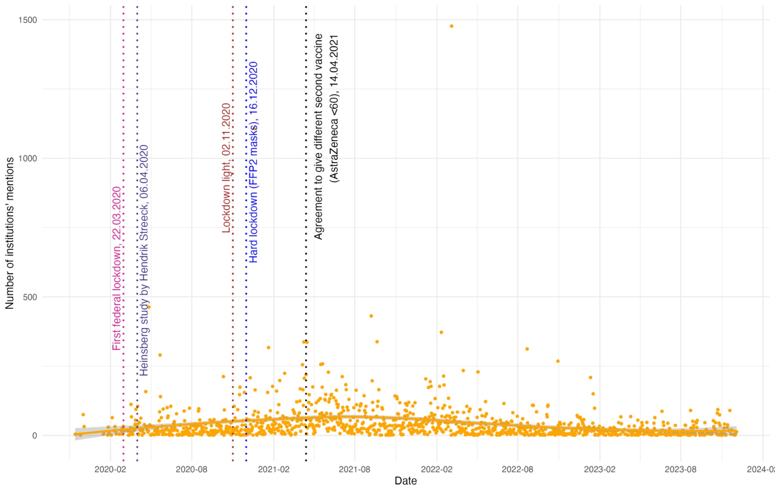
Figure B1. Distribution of neutral sentiment sentences that contain mentions of academic institutions in Telegram posts, a snapshot at the day level: confidence intervals are presented with a shaded area and are produced by the “loess” (local polynomial regression fitting) method. Number of sentences is 90968.

Table B6.
Negative Binomial Regression Estimates for Negative Science-related Sentiment Posts
Variable | Estimate | Std. Error | t-value | p-value
Intercept | 0.649 | 0.287 | 2.26 | 0.020
Trend | 0.009 | 0.001 | 6.48 | <0.001
$${Trend}^{2}$$ | -0.000008 | 0.000 | -5.41 | < 0.001
$${COVID Cases}_{t-1}$$ | -0.0000001 | 0.000 | 0.08 | 0.932
$${COVID Death}_{t-1}$$ | 0.001 | 0.000 | 2.55 | 0.011
$${Negative}_{t-1}$$ | 0.008 | 0.002 | 5.41 | < 0.001
Note. Clustered standard error by month-year; The Augmented Dickey-Fuller test strongly rejects the null of a unit root, indicating that we deal with a stationary process.

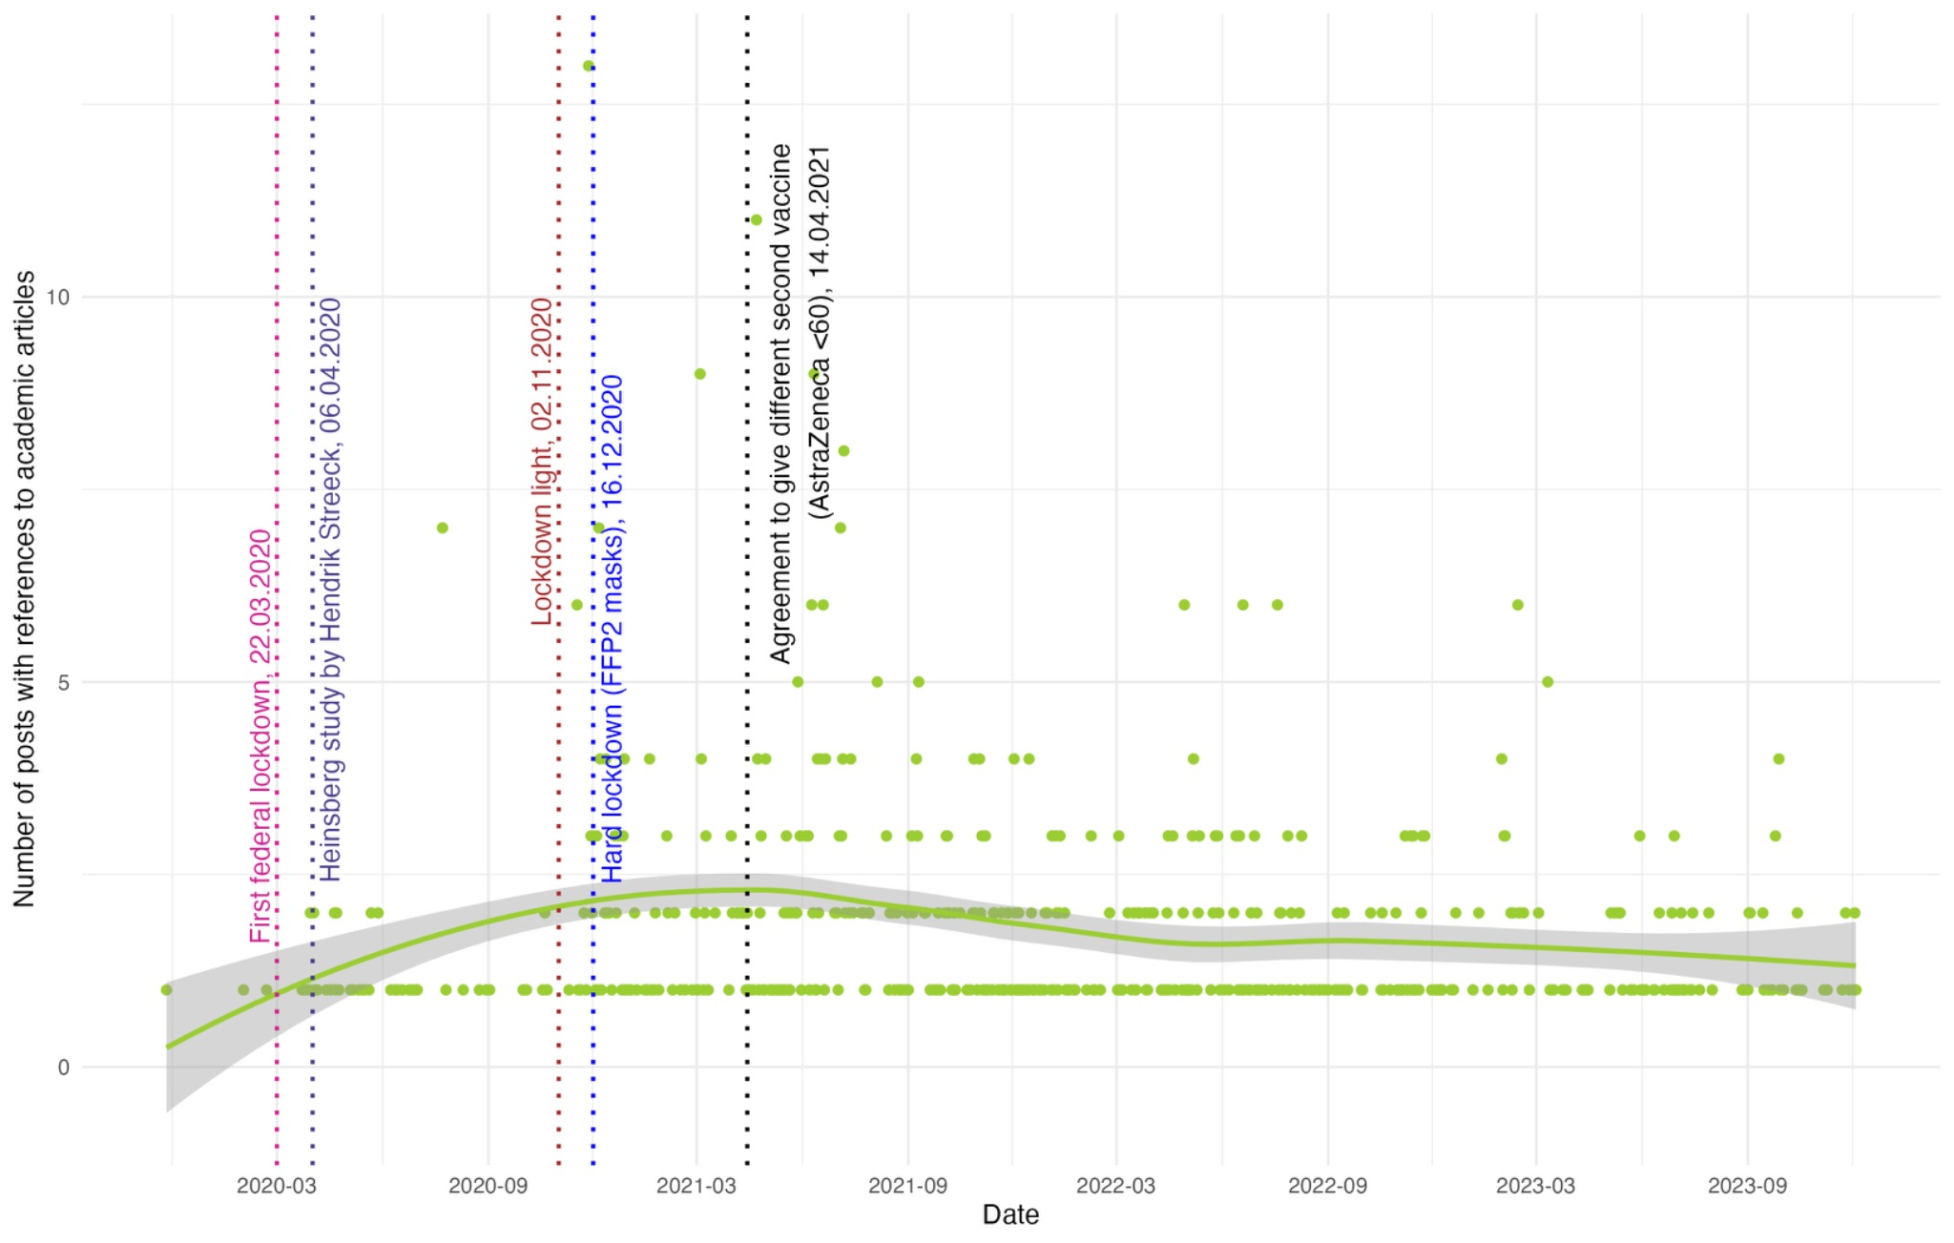
Figure B2. Distribution of Telegram posts mentioning academic articles, a snapshot at the day level: confidence intervals are presented with a shaded area and are produced by the “loess” (local polynomial regression fitting) method. Number of Telegram posts is 870.

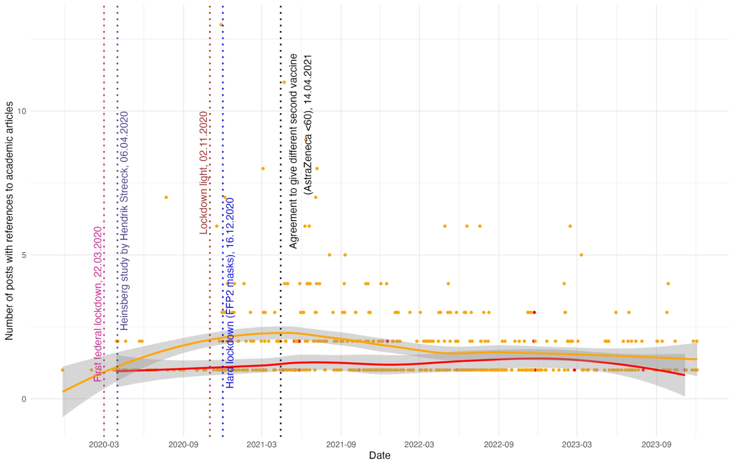
Figure B3. Distribution of positive-, negative- and neutral sentiment posts that contain references to academic articles, a snapshot at the day level: the red line and dots are for negative sentiment, the green line and dots are for positive, the orange line and dots are for neutral sentiment; confidence intervals are presented with a shaded area and are produced by the “loess” (local polynomial regression fitting) method. Number of Telegram posts is 870.

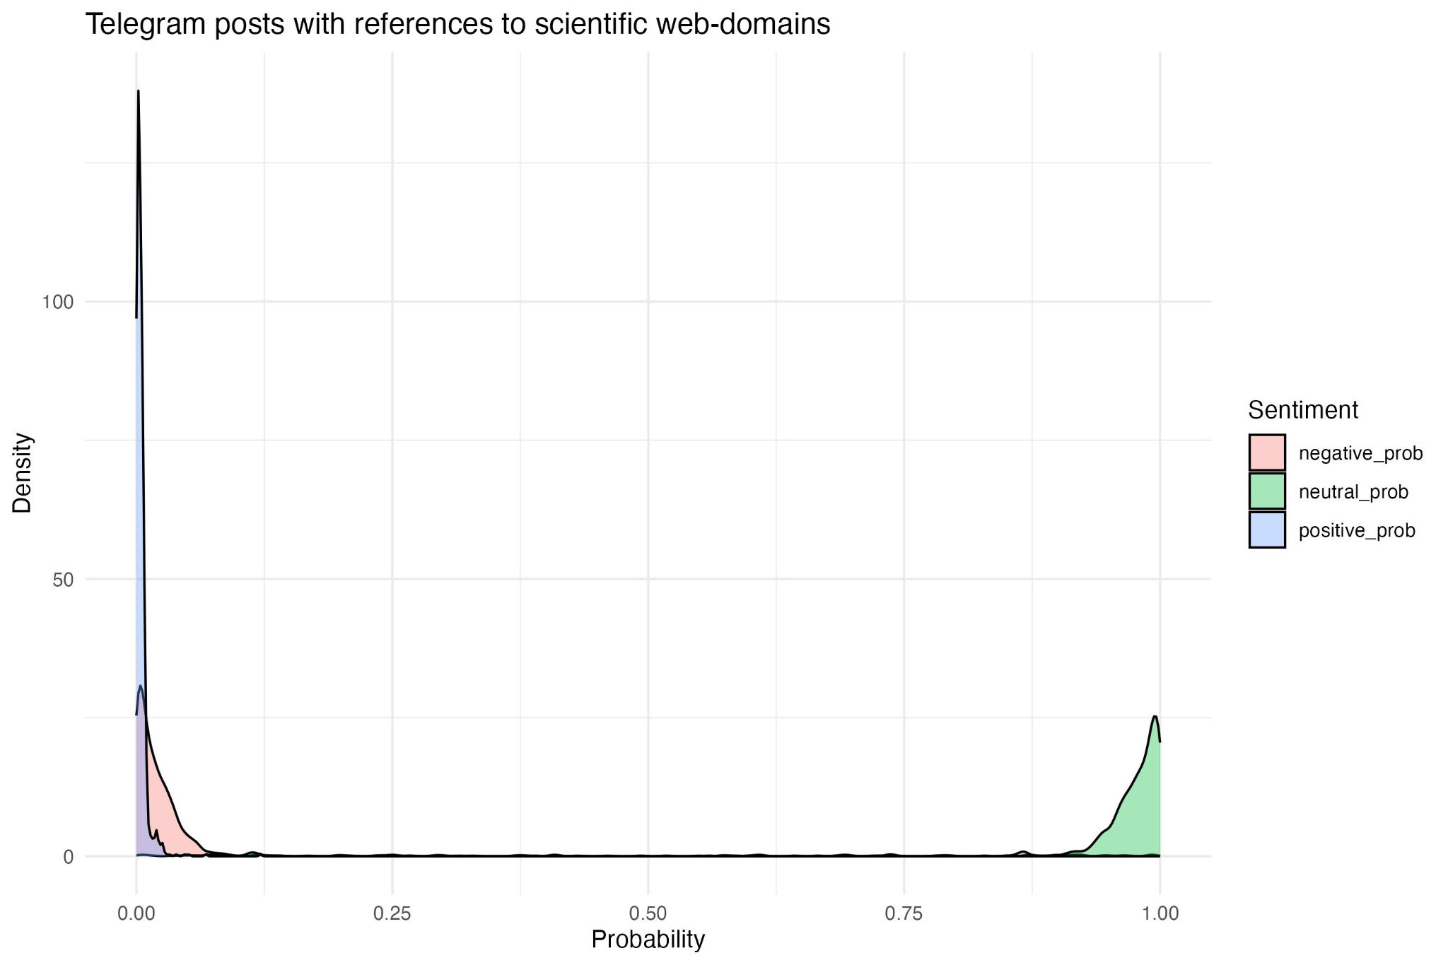
Figure B4. Density plots of sentiment probabilities in Telegram messages mentioning academic publications about COVID-19. The x-axis represents the probabilities of positive sentiment, which range from 0 to 1, while the y-axis represents the density of these probabilities. Number of Telegram messages is 870.

Appendix C. Examples of Telegram posts

Science-related Telegram post
Covid-Impfschäden - Pressekonferenz zur Strafanzeige gegen Swissmedic vom 14.11.2022 https://youtu.be/7rNyZr13ndA 00:00:00 Einleitung (MLaw PHILIPP KRUSE, LL.M., Rechtsanwalt (CH)) 00:09:58 Schilderungen von Impfopfern 00:19:44 Ursachenanalyse und Methodik (Dr. med. URS GUTHAUSER, Facharzt Chirurgie FMH, Gutachter (CH)) 00:25:13 Rechtliche Grundlagen (MLaw PHILIPP KRUSE, LL.M., Rechtsanwalt (CH)) 00:29:43 Besondere Wirkungsweise von mRNA (Prof. Dr. MICHAEL PALMER, Visiting Professor für Pharmakologie/Toxikologie (CAN)) 00:42:57 Fehlende Wirksamkeit der mRNA-Impfstoffe (Prof. Dr. ANDREAS SÖNNICHSEN, Facharzt für Allgemeinmedizin und Innere Medizin (A)) 00:55:23 Risiken der mRNA-Impfstoffe (Prof. Dr. Dr. MARTIN HADITSCH, Facharzt für Hygiene und Mikrobiologie (A)) 01:10:17 Gefährdung der öffentlichen Gesundheit (Prof. Dr. KONSTANTIN BECK, Titularprofessor für Versicherungsökonomie (CH)) 01:23:54 Rechtliche Einordnung (Dr. iur. MARKUS ZOLLINGER, Rechtsanwalt (CH)) 01:29:48 Täuschung der Bevölkerung (lic. iur. JÜRG VOLLENWEIDER, ehem. Leitender Staatsanwalt (CH)) 01:34:31 Mangelnde Marktüberwachung (Dr. iur. MARKUS ZOLLINGER, Rechtsanwalt (CH)) 01:36:10 Würdigung und Forderungen (MLaw PHILIPP KRUSE, LL.M., Rechtsanwalt (CH)) 01:41:45 Fragerunde Quelle: https://coronaanzeige.ch
English Translation by Google Translate:
Covid vaccine damage - Press conference on the criminal complaint against Swissmedic from November 14, 2022 https://youtu.be/7rNyZr13ndA 00:00:00 Introduction (MLaw PHILIPP KRUSE, LL.M., lawyer (CH)) 00:09:58 Descriptions of vaccine victims 00:19:44 Cause analysis and methodology (Dr. med. URS GUTHAUSER, specialist in surgery FMH, expert (CH)) 00:25:13 Legal basis (MLaw PHILIPP KRUSE, LL.M., lawyer (CH)) 00:29:43 Special mode of action of mRNA (Prof. Dr. MICHAEL PALMER, Visiting Professor of Pharmacology/Toxicology (CAN)) 00:42:57 Lack of effectiveness of mRNA vaccines (Prof. Dr. ANDREAS SÖNNICHSEN, Specialist in general medicine and internal medicine (A)) 00:55:23 Risks of mRNA vaccines (Prof. Dr. Dr. MARTIN HADITSCH, specialist in hygiene and microbiology (A)) 01:10:17 Danger to public health (Prof. Dr. KONSTANTIN BECK, titular professor for insurance economics (CH)) 01:23:54 Legal classification (Dr. iur. MARKUS ZOLLINGER, lawyer (CH)) 01:29:48 Deception of the population (lic. iur. JÜRG VOLLENWEIDER, former Chief Public Prosecutor (CH)) 01:34:31 Lack of market surveillance (Dr. iur. MARKUS ZOLLINGER, Attorney at Law (CH)) 01:36:10 Assessment and demands (MLaw PHILIPP KRUSE, LL.M., Attorney at Law (CH)) 01:41:45 Question and answer session Source: https://coronaanzeige.ch

Positive sentiment science-related Telegram post
⬆️Absolut großartiges Interview mit Dr Stefan Lanka. Er steckt hinter der wahnsinnig umfangreichen Virus-Recherche und hat sich bisher eher im Hintergrund gehalten. Es ist offensichtlich, dass seine zunehmende Interview-Präsenz seinen Vortragsstil um ein Vielfaches verbessert hat!
English Translation by Google Translate:
⬆️Absolutely great interview with Dr Stefan Lanka. He is behind the incredibly extensive virus research and has so far stayed in the background. It is obvious that his increasing interview presence has improved his presentation style many times over!

Negative sentiment science-related Telegram post
Das Auswürfeln der jeweils tagesaktuell gültigen Impfanweisungen durch die staatlich verantwortliche Kommission "StIKo" wird immer surrealer. Hier müssen jetzt Rücktritte folgen! Eine derart und permanent und hier sogar wiederholt sich selbst widersprechende Volksverdummung ist unwissenschaftlich, hochgefährlich für Millionen und absolut inakzeptabel! Der Merkelstaat hat sich verrannt, man kann es nicht, man ist offenkundig inkompetent und niemand sollte solchen “Impfexperten” und den von ihnen zugelassenen Stoffen noch trauen!

English Translation by Google Translate:
The rolling of dice to determine the vaccination instructions that are currently valid on a daily basis by the state-run "StIKo" commission is becoming more and more surreal. Resignations must follow! Such permanent and even repeated self-contradictory dumbing down of the people is unscientific, extremely dangerous for millions and absolutely unacceptable! The Merkel state has lost its way, it cannot be done, it is obviously incompetent and no one should trust such “vaccination experts” and the substances they have approved!

Telegram post mentioning scientists

Prof. Dr. Dr. h.c. mult. Jörg Hacker, Präsident des Robert Koch-Instituts (2008 – 2010), Präsident der Deutschen Akademie der Naturforscher Leopoldina (2009 – 2020): “Fast alle haben mitgemacht oder geschwiegen. Auch eine Reihe technischer Angestellter und Verwaltungsmitarbeiter war schon vor 1933 Parteimitglied geworden, der Forschungsbericht erwähnt auch einen Fall von Denunziation. Für das Übertreten humanistischer Grundsätze, für die Verletzung der Würde und der körperlichen Unversehrtheit gibt es zu keiner Zeit der Welt eine Rechtfertigung, auch wenn die Mehrheit ein solches Verhalten toleriert oder gar fordert. Mitgemacht hat auch das RKI als Institution, das aufgrund seiner zentralen Stellung im deutschen Gesundheitswesen erheblich in die nationalsozialistische Gewaltpolitik involviert war.“ Aus: Das Robert Koch-Instituts im Nationalsozialismus (2008) Nun fordert die Leopoldina die “Einführung einer allgemeinen Impfpflicht“ und hält sie für “ethisch und rechtlich gerechtfertigt“.
English Translation by Google Translate:
Prof. Dr. Dr. h.c. mult. Jörg Hacker, President of the Robert Koch Institute (2008–2010), President of the German Academy of Sciences Leopoldina (2009–2020): "Almost everyone either participated or remained silent. A number of technical and administrative employees had also become party members before 1933; the research report also mentions one case of denunciation. There is no justification at any time in the world for the violation of humanistic principles, for the violation of dignity and physical integrity, even if the majority tolerates or even demands such behavior. The RKI, as an institution, also participated, and due to its central position in the German healthcare system, was significantly involved in the National Socialist policy of violence." From: The Robert Koch Institute in National Socialism (2008). Now the Leopoldina is calling for the "introduction of a general vaccination requirement" and considers it "ethically and legally justified."

Sentence mentioning academic institution

Das haben drei Wissenschaftler der renommierten Johns-Hopkins-Universität mithilfe einer großen Meta-Analyse (Analyse zahlreicher Studien aus aller Welt) herausgefunden.“ Kommentar: Was die Studie vermissen lässt, Zahlen zu den gravierenden Kollateralschäden.
English Translation by Google Translate:
This is what three scientists from the renowned Johns Hopkins University discovered with the help of a large meta-analysis (analysis of numerous studies from around the world)." Comment: What the study lacks are figures on the serious collateral damage.

Telegram post mentioning academic publications
„Das ist echt Mist“. Kekule im MDR-Podcast 330: „Diese Daten zeigen klipp und klar, daß es keinen Unterschied gibt in der Schwere der Erkrankung bei einer Zweitinfektion zwischen Geimpften und Ungeimpften. Das ist echt Mist.“ Damit ist eine weitere Impfung/Booster für die etwa 80-85% mind.einmal Infizierten obsolet geworden. Und damit ist auch klar, warum das RKI längst aufgehört hat, den Impfstatus der ITS-Patienten zu veröffentlichen. Er spielt praktisch keine Rolle mehr. Es geht um diese Studie: https://www.nature.com/articles/s41591-022-02051-3 Kekule irrt leider, die Symptome sind bei Geimpften und Ungeimpften gleich bis auf eines: Todesfälle. Hier ist das Risiko für Geimpfte leider deutlich erhöht. Siehe Supplementary Table 4: Ungeimpfte haben bei Reinfektion ein um 67% (gegenüber keiner 2. Infektion) erhöhtes Risiko zu sterben, Geimpfte aber um 97%. Via Richard Strong t.me/Rosenbusch

English Translation by Google Translate:
"This is really crap." Kekule in MDR podcast 330: "These data clearly show that there is no difference in the severity of the disease in a second infection between vaccinated and unvaccinated people. This is really crap." This makes a further vaccination/booster obsolete for the approximately 80-85% of those infected at least once. And this also explains why the RKI long ago stopped publishing the vaccination status of ICU patients. It practically no longer plays a role. The study in question is: https://www.nature.com/articles/s41591-022-02051-3 Kekule is unfortunately mistaken; the symptoms are the same in vaccinated and unvaccinated people except for one thing: death. Here, the risk for vaccinated people is unfortunately significantly increased. See Supplementary Table 4: Unvaccinated individuals have a 67% increased risk of death from reinfection (compared to no second infection), while vaccinated individuals have a 97% increased risk. Via Richard Strong t.me/Rosenbusch

Table C1. List of Telegram channels
Title | ID
HAINTZ.media | haintz
GROSSE FREIHEIT TV | gftv_hh
HermannslandVersand / Lunikoff | hermannsland
Hexogen Outdoor | hexogenoutdoor
SachsenGarde | ibsachsen
Identitäre Bewegung Deutschland | identitaeredeutschland
Identitäre Bewegung Nieder Sachsen | identitaereniedersachsen
Ignaz Bearth offiziell | ignazbearth
Info-DIREKT - Das Magazin für Patrioten | info_direkt
Sven L. aus H. Kanal von und für Freunde(n) und Unterstützer(n) | insvenswelt
Irfan Peci | islamistenjaeger
Juls | julsmusik
JUNGE FREIHEIT – Wochenzeitung für Debatte | junge_freiheit
Freundeskreis Patrioten LSA | jungealternativelsa
Herbert Kickl | hkickl
Junge Nationalisten | jungenationalisten
Jungeuropa | jungeuropa
Karoline Seibt ✨🏹✨🏹✨ | karolineseibt
Kampf der Nibelungen | kdn2013
Ken Jebsen - Aufklärung und Information | kenjebsen
Ketzer der Neuzeit | ketzerderneuzeit
Kilez More [sic!] | kilezmore
Kla.TV - Klagemauer TV | klagemauertv
Klemens Kilic | klemenskilictelegram
Königreich Deutschland Offiziell | koenigreichdeutschland
Krautzone | krautzone
KVLTGAMES | kvltgames
❌ Lapaz Musik | lapazmusikofficial
Laut Gedacht | laut_gedacht
❌Lilly Thüringen 🔨 | lilly_thueringen
Lukreta ✌🏼 | lukreta
LUTZiges - Pegida-Unterstützer | lutzbachmann
🔵 Martin Sellner [TELEGRAMELITE] | martinsellnerib
miesenews | miesenews
Naomi Seibt | naomiseibt
Nation zum Schwert (deleted) | nationzumschwert
Neverforgetniki | neverforgetnikiblog
Nuoviso | nuoviso
1984 - Das Magazin | Oliver Flesch | oliverflesch
Oliver Janich & Team | oliverjanich
Outdoor Germany (deleted) | outdoor_germany
Gordon Pankalla (Herzensanwalt) | pankalla
Patrick Lenart | patricklenart
Paula P'Cay Nachrichten Kanal | paulapcay
PC Records offiziell | pcrecords
PEGIDA - das Original | pegidaoriginal
Philosophia-perennis.com | philosophiaperennisneu
Politik Spezial | politikspezial
PRO CHEMNITZ / Freie Sachsen | prochemnitz
Proto NDS ❌ | prototelegram
🕊Q ANONYMOUS KANAL DEUTSCHesLAND️ 🌍 USA Patriots United | q_anonymous_kanal_deutschland
Qlobal-Change 🇩🇪🇦🇹🇨🇭🇱🇮 🤝 🇷🇺 | qlobalchange
Querdenken Allgäu | querdenken_083
QUERDENKEN (201 - ESSEN) - INFO-Kanal | querdenken_201
Querdenken 211 (Düsseldorf) | querdenken_211
QUERDENKEN (234 - BOCHUM) ⎜ INFO Kanal | querdenken_234
QUERDENKEN (284 - MOERS) - INFO-Kanal | querdenken_284
QUERDENKEN (341 - LEIPZIG) - Orga-Team gesucht | querdenken_341
DRESDEN Ω inBEWEGUNG | querdenken_351
QUERDENKEN (381 - ROSTOCK) - INFO-Kanal | querdenken_381
QUERDENKEN (441 - Oldenburg) - INFO-Kanal | querdenken_441
Q 571 - Minden | INFO-Kanal | querdenken_571
QUERDENKEN-615 DARMSTADT INFO-Kanal | querdenken_615
QUERDENKEN (621 - MANNHEIM) - INFO-Kanal | querdenken_621
Querdenken 69 Frankfurt / Info Channel | querdenken_69
QUERDENKEN (711 - STUTTGART) - INFO-Kanal | querdenken_711
🔴Querdenken (713) - Wir für unsere Grundrechte_info | querdenken_713_info
QUERDENKEN_7171 | querdenken_7171
QUERDENKEN (718 - SCHORNDORF) - INFO-Kanal | querdenken_718
QUERDENKEN (721 - KARLSRUHE) - INFO-Kanal | querdenken_721
QUERDENKEN_(722 - BÜHL-BADEN) - INFO-KANAL | querdenken_722
QUERDENKEN (I) 775 - WALDSHUT- TIENGEN) - INFO-Kanal | querdenken_775
QUERDENKEN (791 - SCHWÄBISCH HALL) - INFO-Kanal | querdenken_791
QUERDENKEN (794 - ÖHRINGEN) - INFO-Kanal, Deleted | querdenken_794
QUERDENKEN (911 – NÜRNBERG) – INFO-Kanal | querdenken_911
QUERDENKEN (511 - HANNOVER) INFO-Kanal | querdenken511
für Respekt, Toleranz, Meinungsfreiheit, Selbstbestimmung mit Eigenverantwortung | querdenker_braucht_die_welt
RAPBELLIONS | rapbellions
ScienceFiles | realsciencefiles
Reiner Fuellmich 🇩🇪/🇦🇹/🇨🇭 | reinerfuellmich
ROCK HATE | rockhate
RT Deutsch, deleted | rtdeutsch_rtde
❌ Runa_Offiziell_ | runatelegram
💡Samuel Eckert💡 | samueleckert
Schmidtkes Welt | schmidtkeswelt
Der Mob aus der Shlomosphäre | shlomobbing
Siegfried Däbritz, deleted | siegfrieddaebritz
Silberjunge Thorsten Schulte OFFIZIELL | silberjungethorstenschulte
Sonnenkreuz Versand | sk_versand
Soldaten & Reservisten | soldaten_und_reservisten
Kanal Sturmzeichen | sturmzeichen
SUB:VERSION PRODUCTION © | sub_version_production
sundaysforlife | sundaysforlife
Tim K. | timmkellner
❌ Twanie Rapbellions ❌ | twanie47
Ukvali | ukvali
MIRÓ | unblogd
unzensuriert | unzensuriert
Volksanwalt Mandic - Anwalt für Meinungsfreiheit | volksanwalt
Wahrheitsträumer | wahrheitstraeumer
#WIDERSTAND CHANNEL | widerstandberlin
#WirSindVielMehr | wirsindvielmehr
achse:ostwest | achseostwest
❤️ Corona Ausschüsse Informationen, Ärzte für Aufklärung, Stiftung Corona Ausschuss Runder Tisch 2020 | aerztefueraufklaerung
Ärzte für Aufklärung offiziell | aerztefueraufklaerungoffiziell
Nationalrevolutionäre Jugend - NRJ (Der III. Weg) | agjugend
Aktivist Mann & Team | aktivistmann
Malenki | alex_malenki
Alles Ausser Mainstream | allesaussermainstream
ANSGAR ARYAN | ansgararyan
apolut. | apolut
AUF1 | auf1tv
Aya Velázquez | ayawasgeht
Bewusst TV - Jo Conrad | bewussttv
Billy Six - Sonderablage | billsix
Björn Höcke | bjoernhoeckeafd
Blaupause.tv - Patrick Schönerstedt | blaupausetv
BlickpunktTV | blickpunkttv
❌ BUST3K | bustek
COMPACT-Magazin | compactmagazin
corona-ausschuss.de | corona_ausschuss
Dave Brych Kanal | davebrych_public
DeutschlandKURIER | dekurier
Demokratie Freiheit Souveränität, deleted | demokratiefreiheitsouveraenitaet
28. März | Arbeiter- & Bauernmacht für Frieden & Freiheit | demokratischerwiderstandtelegram
Demo-Termine & Kontakte, Gleichgesinnte treffen - Demokalender, Spaziergänge, Mahnwachen, Meditation *Rücktritt Bundesregierung! | demotermine
Der Volkslehrer | der_volkslehrer
🎙 Der dritte Blickwinkel 🔊 | derdritteblickwinkel
Der III. Weg (Der Dritte Weg) | derdritteweg
dieBasis funkt | die_basis_funkt
Die Rechte Braunschweig Hildesheim | dierechtebshi
ehem. DIE RECHTE Infokanal | dierechteinfo
Die Wahrheit ist das was zählt, deleted | diewahrheitistdaswaszaehlt
Digitaler Chronist | digitalchronist
Digital Soldiers Germany News, deleted | digitalsoldiersgermanynews
Heimat Dortmund | dortmundsrechte
📰 Newsletter Eltern für Aufklärung und Freiheit | efauf_newsletter
eigentümlich frei | efmagazin
Ehrenfrau TV | ehrenfrautv
Ein Prozent | ein_prozent
🍷 eingeSCHENKt.TV | eingeschenkt
Epoch Times Deutsch | epochtimesde
Eva Herman Offiziell | evahermanoffiziell
Friedensfreunde2024 | evarosen
ExoMagazin.tv | exomagazin
ExpressZeitung TV - die kritische Monatszeitung | expresszeitung
Fakten Frieden Freiheit | faktenfriedenfreiheit
Filmkunst Kollektiv, deleted | filmkunstkollektiv
Frank Franz | frankfranz
🎙 Frank Kraemer | frankkraemer
Freie Geister - Wilde Herzen | freiegeisterwildeherzen
Freie Medien | freiemedientv
Freie Sachsen Vogtland | freiesachsen_vogtl
Freie Sachsen | freiesachsen
Freie Sachsen Leipzig | freiesachsenle
Freiheitsboten und Digitale Freiheitsboten | freiheitsboten
friedensvertrag, deleted | friedensvertrag
FSN - The Revolution | fsnrev
Genticus Kanal 💬 | genticus
Gerald Grosz | geraldgroszofficial

References

Ahir, H., Bloom, N., & Furceri, D. (2022). The world uncertainty index (No. w29763). National bureau of economic research.
Bossetta M., Segesten A. D., & Bonacci D. (2023) Reconceptualizing Cross-Cutting Political Expression on Social Media: A Case Study of Facebook Comments During the 2016 Brexit Referendum, Political Communication, 40:6, 719-741, DOI: 10.1080/10584609.2023.2222370
Chan, C. H., & Sältzer, M. (2020). oolong: An R package for validating automated content analysis tools. The Journal of Open Source Software: JOSS, 5(55), 2461.
Chang, J., Gerrish, S., Wang, C., Boyd-Graber, J., & Blei, D. (2009). Reading tea leaves: How humans interpret topic models. Advances in neural information processing systems, 22.
Gelman, A. (2007). Data analysis using regression and multilevel/hierarchical models. Cambridge university press.
Grimmer, J., Roberts, M. E., & Stewart, B. M. (2022). Text as data: A new framework for machine learning and the social sciences. Princeton University Press
Guhr, O., Schumann, A.-K., Bahrmann, F., & Böhme, H. J. (2020). Training a broad-coverage German sentiment classification model for dialog systems. In Proceedings of The 12th Language Resources and Evaluation Conference (pp. 1620–1625). European Language Resources Association. https://www.aclweb.org/anthology/2020.lrec-1.202
Holman, E. A., Thompson, R. R., Garfin, D. R., & Silver, R. C. (2020). The unfolding COVID-19 pandemic: A probability-based, nationally representative study of mental health in the United States. Science advances, 6(42), eabd5390.
Honnibal, M., & Montani, I. (2017). spaCy 2: Natural language understanding with Bloom embeddings, convolutional neural networks and incremental parsing.
Jiang, A. Q., Sablayrolles, A., Roux, A., Mensch, A., Savary, B., Bamford, C., Chaplot, D. S., de las Casas, D., Bou Hanna, E., Bressand, F., Lengyel, G., Bour, G., Lample, G., Lavaud, L. R., Saulnier, L., Lachaux, M.-A., Stock, P., Subramanian, S., Yang, S., Antoniak, S., Le Scao, T., Gervet, T., Lavril, T., Wang, T., Lacroix, T., & El Sayed, W. (2024). Mixtral of experts. arXiv. https://doi.org/10.48550/arXiv.2401.04088
Jost, P., & Dogruel, L. (2023). Radical mobilization in times of crisis: Use and effects of appeals and populist communication features in Telegram channels. Social Media+ Society, 9(3), 20563051231186372.
Kubiczek, J., & Hadasik, B. (2021). Challenges in Reporting the COVID-19 Spread and its Presentation to the Society. Journal of Data and Information Quality (JDIQ), 13(4), 1-7.
Mimno, D., & Lee, M. (2014, October). Low-dimensional embeddings for interpretable anchor-based topic inference. In Proceedings of the 2014 conference on empirical methods in natural language processing (EMNLP) (pp. 1319-1328).
Leidecker-Sandmann, M., Attar, P., Schütz, A., & Lehmkuhl, M. (2022). Selected by expertise? Scientific experts in German news coverage of COVID-19 compared to other pandemics. Public Understanding of Science, 31(7), 847-866.
Thompson, R. N. (2020). Epidemiological models are important tools for guiding COVID-19 interventions. BMC medicine, 18, 1-4.
Roberts, M.E., Stewart, B.M., & Tingley, D. (2019). “stm: An R Package for Structural Topic Models”. In: Journal of Statistical Software 91.2, pp. 1–40. url: https://www.jstatsoft.org/index.php/jss/article/view/v091i02.
Yarchi M., Baden C., & Kligler-Vilenchik N. (2021) Political Polarization on the Digital Sphere: A Cross-platform, Over-time Analysis of Interactional, Positional, and Affective Polarization on Social Media, Political Communication, 38:1-2, 98-139, DOI: 10.1080/10584609.2020.1785067

The original German keywords: "Forschung*", "wissenschaftlich*", "Wissenschaft*", "Studie*", "Professor*", "Doctor*", "mRNA", "Spike*", "Mykoplasmen", "pathologen*", "Virolog*", "Grundimmunität*", "Virusexistenz*", "Virenexistenz*", "Virusnachweis*", "Virennachweis*", "anaerob*", "Antikörper*", "Statistik*", "Evidenz*", "Kontrollexperiment*", "empiri*", "akadem*", "Korrelation*", "Modell*", "Hypothese", "Metaanalyse*", "Review*", "Preprint*", "Erhebung*", "Fachmagazin*", "Fachjournal*", "Fachblatt*", "Fachblätt*", "Fachartikel*", "unwissenschaftlich*", "Nobelpreisträger*", "Gen*", "Virusstruktur*", "Labor*", "Erforsch*", "Paper", "Fach*", "Vorträge", "Vortrag", "Symposium*", "Hypothese*"
https://www.ecdc.europa.eu/en/publications-data/data-daily-new-cases-covid-19-eueea-country
https://worlduncertaintyindex.com/data/
https://www.destatis.de/EN/Themes/Economy/Short-Term-Indicators/Labour-Market/arb120.html#241586
​​https://www.destatis.de/EN/Themes/Economy/Short-Term-Indicators/Labour-Market/arb130.html#241598
https://t.me/twanie47/1929
https://t.me/karolineseibt/7204
https://t.me/aerztefueraufklaerung/7097
https://t.me/GFTV_HH/12138
https://t.me/Haintz/20797
https://t.me/GFTV_HH/14829

