Mass Media Use and Public Attitudes toward Quantum Science

Supplementary Material

SM1. Table of Sample Characteristics
SM2. Table of Information Source Distribution and Descriptive Statistics
SM3. Table of Factor Loadings of Information Sources from Exploratory Factor Analysis
SM4. Table of Product Moment Correlations of Key Variables
SM5. Table of Indirect and Total Effects of Media Use and Interest in Quantum Science
SM6. Question Wording

SM1. Table of Sample Characteristics
Table 1
Sociodemographic Characteristics of Overall and Quantum Science Aware Respondents
 | Characteristic | Group | Total  n | Total  % | Aware n | Aware %
 | Age
 |  | 18-24 | 104 | 8.99 | 86 | 9.36
 |  | 25-34 | 268 | 23.16 | 221 | 24.05
 |  | 35-44 | 176 | 15.21 | 151 | 16.43
 |  | 45-54 | 233 | 20.14 | 185 | 20.13
 |  | 55-64 | 201 | 17.37 | 148 | 16.10
 |  | 65+ | 175 | 15.13 | 128 | 13.93
 | Gender
 | Gender | Male | 576 | 49.83 | 513 | 55.82
 | Gender | Female | 578 | 50.00 | 404 | 43.96
 | Gender | Non-binary/ third gender | 2 | 0.17 | 2 | 0.22
 | Race
 | Race | White or Caucasian | 919 | 79.43 | 712 | 77.48
 | Race | Black or African American | 161 | 13.92 | 146 | 15.89
 | Race | American Indian/Native American or Alaska Native | 14 | 1.21 | 12 | 1.31
 | Race | Asian | 65 | 5.62 | 52 | 5.66
 | Race | Native Hawaiian or Other Pacific Islander | 6 | 0.52 | 4 | 0.44
 | Race | Other | 25 | 2.16 | 19 | 2.07
 |  | Prefer not to say | 4 | 0.35 | 3 | 0.33
 | Education
 | Education | Some high school or less | 2 | 0.17 | 1 | 0.11
 | Education | High school diploma or GED | 123 | 10.64 | 76 | 8.28
 | Education | Some college, but no degree | 225 | 19.46 | 182 | 19.83
 | Education | Associates or technical degree | 158 | 13.67 | 125 | 13.62
 | Education | Bachelor’s degree | 461 | 39.88 | 384 | 41.83
 | Education | Graduate or professional degree | 186 | 16.09 | 149 | 16.23
 | Education | Prefer not to say* | 1 | 0.09 | 1 | 0.11
STEM Major**
 |  | No | 726 | 70.42 | 563 | 66.94
 |  | Maybe | 31 | 3.01 | 28 | 3.33
 |  | Yes | 274 | 26.58 | 250 | 29.73
Income
 |  | Less than $25,000 | 137 | 11.84 | 105 | 11.43
 |  | $25,000 - $49,999 | 262 | 22.64 | 201 | 21.87
 |  | $50,000 - $74,999 | 266 | 22.99 | 205 | 22.31
 |  | $75,000 - $99,999 | 180 | 15.56 | 145 | 15.78
 |  | $100,000 - $149,999 | 194 | 16.77 | 164 | 17.85
 |  | $150,000 or more | 102 | 8.82 | 89 | 9.68
 |  | Prefer not to say* | 16 | 1.38 | 10 | 1.09
 | Marital Status
 | Marital Status | Married | 460 | 39.79 | 361 | 39.32
 | Marital Status | Widowed | 38 | 3.29 | 27 | 2.94
 | Marital Status | Divorced | 165 | 14.27 | 127 | 13.83
 | Marital Status | Separated | 19 | 1.64 | 15 | 1.63
 | Marital Status | Never Married | 474 | 41.00 | 388 | 42.27
 | Party Identification
 | Party Identification | Strong Democrat | 309 | 26.80 | 242 | 26.42
 | Party Identification | Not very strong Democrat | 223 | 19.34 | 182 | 19.87
 | Party Identification | Independent | 303 | 26.28 | 247 | 26.97
 | Party Identification | Not very strong Republican | 145 | 12.58 | 123 | 13.43
 | Party Identification | Strong Republican | 141 | 12.23 | 102 | 11.14
 |  | Other* | 10 | 0.87 | 8 | 0.87
 |  | No preference* | 22 | 1.91 | 12 | 1.31
 | Political Ideology
 |  | Very liberal | 185 | 15.99 | 143 | 15.56
 |  | Mostly liberal | 245 | 21.18 | 194 | 21.11
 |  | Somewhat liberal | 158 | 13.66 | 133 | 14.47
 |  | Moderate | 233 | 20.14 | 184 | 20.02
 |  | Somewhat conservative | 140 | 12.10 | 116 | 12.62
 |  | Mostly conservative | 119 | 10.29 | 98 | 10.66
 |  | Very conservative | 77 | 6.66 | 51 | 5.55
Note 1. * These options were coded as missing in data analysis.
Note 2. ** This question was asked to respondents who indicated “Some college, but no degree” or higher education levels.

SM2. Table of Information Source Distribution and Descriptive Statistics
Table 2
Information Source Distribution and Descriptive Statistics¹
Sources² | n  (%) |  |  |  |  | M | SD
 | 1³ | 2³ | 3³ | 4³ | 5³
Books | 306  (33.30) | 301  (32.75) | 223  (24.27) | 72  (7.83) | 17  (1.85) | 2.12 | 1.02
Documentaries | 139  (15.13) | 278  (30.25) | 349  (37.98) | 120  (13.06) | 33  (3.59) | 2.60 | 1.01
TV series | 183  (19.91) | 297  (32.32) | 298  (32.43) | 99  (10.77) | 42  (4.57) | 2.48 | 1.07
Games | 483  (52.56) | 226  (24.59) | 130  (14.15) | 62  (6.75) | 18  (1.96) | 1.81 | 1.04
Science blogs or websites | 177  (19.26) | 249  (27.09) | 295  (32.10) | 157  (17.08) | 41  (4.46) | 2.60 | 1.11
Podcasts | 419  (45.59) | 236  (25.68) | 182  (19.80) | 63  (6.86) | 19  (2.07) | 1.94 | 1.05
Local TV | 555  (60.39) | 226  (24.59) | 96  (10.45) | 31  (3.37) | 11  (1.20) | 1.60 | 0.89
National network TV | 361  (39.28) | 338  (36.78) | 166  (18.06) | 39  (4.24) | 15  (1.63) | 1.92 | 0.94
CNN | 543  (59.09) | 217  (23.61) | 120  (13.06) | 28  (3.05) | 11  (1.20) | 1.64 | 0.91
MSNBC | 607  (66.05) | 183  (19.91) | 86  (9.36) | 31  (3.37) | 12  (1.31) | 1.54 | 0.89
FOX News | 679  (73.88) | 129  (14.04) | 71  (7.73) | 30  (3.26) | 10  (1.09) | 1.44 | 0.85
Print or online newspapers | 379  (41.24) | 289  (31.45) | 192  (20.89) | 41  (4.46) | 18  (1.96) | 1.94 | 0.99
Print or online magazines | 342  (37.21) | 261  (28.40) | 237  (25.79) | 62  (6.75) | 17  (1.85) | 2.08 | 1.03
Public radio (e.g., NPR) | 489  (53.21) | 245  (26.66) | 145  (15.78) | 27  (2.94) | 13  (1.41) | 1.73 | 0.93
Facebook | 504  (54.84) | 210  (22.85) | 138  (15.02) | 50  (5.44) | 17  (1.85) | 1.77 | 1.01
Instagram | 582  (63.33) | 163  (17.74) | 109  (11.86) | 46  (5.01) | 19  (2.07) | 1.65 | 1.01
X (formerly Twitter) | 484  (52.67) | 175  (19.04) | 149  (16.21) | 73  (7.94) | 38  (4.13) | 1.92 | 1.17
YouTube | 233  (25.35) | 222  (24.16) | 270  (29.38) | 137  (14.91) | 57  (6.200) | 2.52 | 1.20
TikTok | 622  (67.68) | 138  (15.02) | 89  (9.68) | 50  (5.44) | 20  (2.18) | 1.59 | 1.01
Discussions w/ family | 462  (50.27) | 236  (25.68) | 159  (17.30) | 45  (4.90) | 17  (1.85) | 1.82 | 1.00
Discussions w/ friends | 363  (39.50) | 257  (27.97) | 226  (24.59) | 54  (5.88) | 19  (2.07) | 2.03 | 1.03
Discussions w/ coworkers | 555  (60.39) | 186  (20.24) | 117  (12.73) | 47  (5.11) | 14  (1.52) | 1.67 | 0.98
Note 1. The sample includes respondents who are aware of quantum science and technology (n = 919).
Note 2. Respondents were asked “How often have you heard, read, or seen quantum science and technology information from each of the following sources or places?”
Note 3. 1 = Never, 2 = Rarely, 3 = Occasionally, 4 = Frequently, 5 = Very frequently

SM3. Table of Factor Loadings of Information Sources from Exploratory Factor Analysis
Table 1
Factor Loadings of Information Sources from Exploratory Factor Analysis
 | Factor 1 | Factor 2 | Factor 3
Books | 0.25 | 0.06 | 0.42
Documentaries | 0.34 | -0.05 | 0.43
TV series | 0.26 | 0.06 | 0.38
Games | 0.49 | 0.03 | 0.21
Science blogs or websites | 0.27 | -0.13 | 0.56
Podcasts | 0.48 | -0.07 | 0.29
Local TV | 0.21 | 0.59 | 0.02
National network TV | -0.01 | 0.66 | 0.17
CNN | -0.06 | 0.88 | 0.10
MSNBC | 0.04 | 0.86 | 0.03
FOX News | 0.25 | 0.70 | -0.10
Print or online newspapers | -0.17 | 0.27 | 0.70
Print or online magazines | -0.16 | 0.06 | 0.88
Public radio (e.g., NPR) | -0.03 | 0.32 | 0.48
Facebook | 0.69 | 0.12 | -0.06
Instagram | 0.82 | 0.22 | -0.19
X (formerly Twitter) | 0.75 | 0.12 | -0.05
YouTube | 0.67 | -0.18 | 0.25
TikTok | 0.82 | 0.12 | -0.19
Discussions w/ family | 0.43 | 0.09 | 0.16
Discussions w/ friends | 0.56 | -0.08 | 0.31
Discussions w/ coworkers | 0.42 | 0.19 | 0.22
Note. Reported are factor loadings from an exploratory factor analysis with promax rotation and maximum likelihood method. Factor 1 and Factor 2 are correlated at .67, Factor 1 and Factor 3 are correlated at .74, and Factor 2 and Factor 3 are correlated at .63. The “discussion with friends” item also met our criterion to retain an item (loading on the dominant factor exceeding .55 and loadings on other factors do not exceed .33); however, this item was not included in Factor 1 because it did not fit the construct of social media use indicated by the other items that loaded on the factor.

SM4. Table of Product Moment Correlations of Key Variables
Table 3
Product Moment Correlations Between Information Sources and Knowledge/Attitudes about Quantum Science
Variables | M | SD | 1 | 2 | 3 | 4 | 5 | 6 | 7 | 8
1 TV use | 1.63 | 0.78 | 1.00
2 Print/online media use | 2.21 | 0.87 | .61*** | 1.00
3 Social media use | 1.89 | 0.89 | .69*** | .63*** | 1.00
4 Interest | 5.31 | 1.16 | .17*** | .42*** | .31*** | 1.00
5 Knowledge | 3.03 | 1.67 | .08* | .34*** | .21*** | .42*** | 1.00
6 Benefits | 3.43 | 0.94 | .29*** | .36*** | .34*** | .47*** | .29*** | 1.00
7 Risks | 1.96 | 0.93 | .31*** | .20*** | .30*** | .01 | -.03 | .05 | 1.00
8 Support | 5.64 | 1.07 | .09** | .31*** | .15*** | .59*** | .41*** | .58*** | -.14*** | 1.00
Note. * p < .05, ** p < .01, *** p < .001.
SM5. Table of Indirect and Total Effects of Media Use and Interest in Quantum Science
Table 4
Indirect and Total Effects of Media Use and Interest in Quantum Science
Paths | B (SE) | β | p
Indirect Effects
TV à Interest à Knowledge | -0.111 (0.029) | -.052 | <.001
TV à Interest à Benefits | -0.076 (0.019) | -.063 | <.001
TV à Interest à Risks | -0.010 (0.008) | -.008 | .249
TV à Interest à Support | -0.076 (0.020) | -.056 | <.001
TV à Interest à Knowledge à Support | -0.009 (0.003) | -.007 | .002
TV à Interest à Benefits à Support | -0.028 (0.007) | -.021 | <.001
TV à Interest à Risks à Support | -0.001 (0.001) | -.001 | .270
TV à Knowledge à Support | -0.037 (0.011) | -.027 | .001
TV à Benefits à Support | 0.059 (0.019) | .043 | .002
TV à Risks à Support | -0.021 (0.010) | -.016 | .029
POM à Interest à Support | 0.136 (0.021) | .112 | <.001
POM à Interest à Knowledge | 0.198 (0.032) | .105 | <.001
POM à Interest à Benefits | 0.136 (0.020) | .128 | <.001
POM à Interest à Risks | -0.017 (0.015) | -.017 | .242
POM à Interest à Knowledge à Support | 0.017 (0.004) | .014 | <.001
POM à Interest à Benefits à Support | 0.050 (0.009) | .041 | <.001
POM à Interest à Risks à Support | 0.002 (0.002) | .002 | .261
POM à Knowledge à Support | 0.034 (0.010) | .028 | .001
POM à Benefits à Support | 0.014 (0.018) | .012 | .414
POM à Risks à Support | -0.002 (0.006) | -.002 | .722
SM à Interest à Support | 0.093 (0.022) | .079 | <.001
SM à Interest à Knowledge | 0.136 (0.032) | .074 | <.001
SM à Interest à Benefits | 0.094 (0.020) | .090 | <.001
SM à Interest à Risks | -0.012 (0.010) | -.012 | .246
SM à Interest à Knowledge à Support | 0.011 (0.003) | .010 | <.001
SM à Interest à Benefits à Support | 0.034 (0.008) | .029 | <.001
SM à Interest à Risks à Support | 0.001 (0.001) | .001 | .267
SM à Knowledge à Support | 0.021 (0.009) | .018 | .015
SM à Benefits à Support | -0.000 (0.019) | -.000 | .991
SM à Risks à Support | -0.023 (0.009) | -.019 | .014
Interest à Knowledge à Support | 0.034 (0.008) | .037 | <.001
Interest à Benefits à Support | 0.104 (0.015) | .113 | <.001
Interest à Risks à Support | 0.004 (0.004) | .005 | .257
Total Effects
TV à Knowledge | -0.551 (0.090) | -.258 | <.001
TV à Benefits | 0.084 (0.055) | .069 | .130
TV à Risks | 0.192 (0.067) | .161 | .004
TV à Support | -0.114 (0.039) | -.084 | .004
POM à Knowledge | 0.606 (0.078) | .320 | <.001
POM à Benefits | 0.176 (0.048) | .164 | <.001
POM à Risks | 0.001 (0.048) | .001 | .986
POM à Support | 0.251 (0.033) | .208 | <.001
SM à Knowledge | 0.391 (0.087) | .211 | <.001
SM à Benefits | 0.093 (0.054) | .089 | .082
SM à Risks | 0.182 (0.059) | .176 | .002
SM à Support | 0.139 (0.035) | .117 | <.001
Interest à Support | 0.425 (0.033) | .464 | <.001
Note: POM = print/online media. SM = social media.

SM6. Question Wording
Screening Question
How much have you ever heard, read, or seen quantum science and technology? (1 = Not at all; 2 = A little; 3 = A moderate amount; 4 = A lot; 5 = A great deal)
Information Sources
How often have you heard, read, or seen quantum science and technology information from each of the following sources or places? (1 = Never; 2 = Rarely; 3 = Occasionally; 4 = Frequently; 5 = Very frequently)
- Books
- Documentaries or films
- TV series
- Games
- Science blogs or websites
- Podcasts
- Local TV
- National network TV
- CNN
- MSNBC
- FOX News
- Print or online newspapers
- Print or online magazines
- Public radio
- Facebook
- Instagram
- X (formerly Twitter)
- YouTube
- TikTok
- Interpersonal discussions with family members
- Interpersonal discussions with friends
- Interpersonal discussions with coworkers
Interest in quantum science and technology
To what extent do you agree with each of the following statements? (1= Strongly disagree; 2 = Disagree; Somewhat disagree; 4 = Neither agree nor disagree; 5 = Somewhat agree; 6 = Agree; 7 = Strongly agree)
- I am interested in learning about quantum science and technology.
- I find the debate surrounding quantum science and technology interesting.
- I want to learn more about quantum science and technology.
- I find quantum science and technology exciting.
- I find quantum science and technology ideas thought-provoking.
Benefit perception
How beneficial do you think quantum science and technology would be for: (1 = Not beneficial at all; 2 = Slightly beneficial; 3 = Moderately beneficial; 4 = Very beneficial; 5 = Extremely beneficial)
- society as a whole?
- you personally?
Risk perception
How serious of a threat do you believe quantum science and technology is to: (1= Not series at all; 2 – Slightly series; 3 = Moderately series; 4 = Very serious; 5 = Extremely serious)
- society as a whole?
- you personally?
Support for quantum science
To what extent do you agree with each of the following statements? (1= Strongly disagree; 2 = Disagree; Somewhat disagree; 4 = Neither agree nor disagree; 5 = Somewhat agree; 6 = Agree; 7 = Strongly agree)
- I support federal funding for basic quantum science and technology research.
- I support federal funding for applied quantum science and technology research.
- I support the development of quantum science and technology.
- I support the use of quantum science and technology.
Deference to scientific authority
To what extent do you agree with each of the following statements? (1= Strongly disagree; 2 = Disagree; Somewhat disagree; 4 = Neither agree nor disagree; 5 = Somewhat agree; 6 = Agree; 7 = Strongly agree)
- Scientists know best what is good for the public.
- Scientists should do what they think is best for the society, even if they have to persuade people that it is right.
- Scientists should make the decisions about the type of scientific research on quantum science and engineering.
- It is important for scientists to get research about quantum science and engineering done even if they displease people by doing it.
Objective Factual Knowledge Questions (Correct answers are bolded)
- Is this statement true or false? (Source: self-developed)
In simple terms, quantum theory describes the behavior of macroscopic (or very large) things. (F)
- Is this statement true or false? (Source: https://new.nsf.gov/science-matters/curious-about-quantum)
Many well-known devices operate using the principles of quantum mechanics, from lasers to Magnetic Resonance Imaging (MRI) machines. (T)
- Quantum particles can be far apart while their states remain connected. What is this phenomenon called? (Source: self-developed)
  - Entanglement
  - Superposition
  - Contextuality
  - Don’t Know
- What does this image show about quantum science and technology?
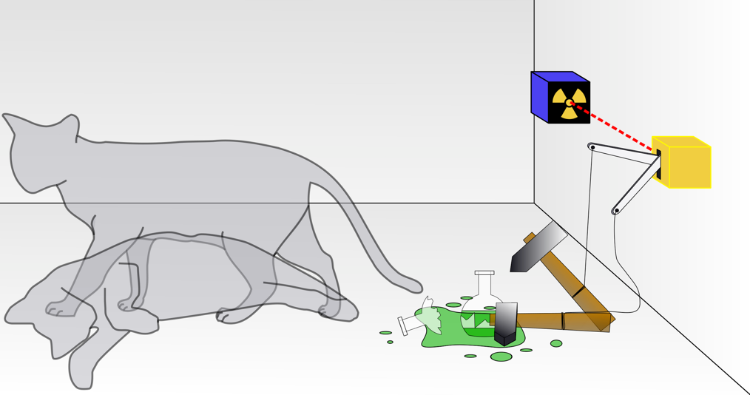
(Image Source: https://en.wikipedia.org/wiki/Schr%C3%B6dinger%27s_cat; By Dhatfield - Own work, CC BY-SA 3.0, https://commons.wikimedia.org/w/index.php?curid=4279886)
(Source: question adapted from (Merbel et al., 2024))
  - A thought experiment about the probability of quantum states
  - Creating a chain reaction wherein a cat faints
  - The influence of radioactive particles on a cat
  - Testing the speed at which a cat responds
  - I don’t know.
- Which concept about quantum science and technology does this image best illustrate?
(Image Source: https://en.wikipedia.org/wiki/Schr%C3%B6dinger%27s_cat; By Dhatfield - Own work, CC BY-SA 3.0, https://commons.wikimedia.org/w/index.php?curid=4279886)
  - Superposition
  - Entanglement
  - Contextuality
  - I don’t know.
- What does the image above show about quantum science and technology?
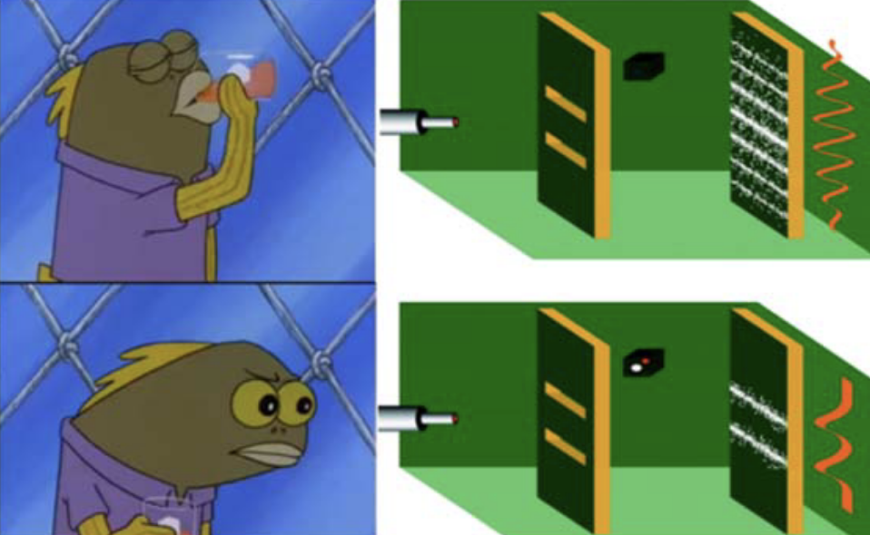
(Source: question adapted from (Merbel et al., 2024))
  - You can never know the exact location and speed of a particle.
  - Measuring a particle can change its behavior.
  - How can particles be shot as fast and precisely as possible.
  - Thinking hard about small particles can give a different outcome.
  - I don’t know.

Age
How old are you? (1 = 18-24 years old; 2 = 25-34 years old ; 3 = 35-44 years old; 4 = 45-54 years old; 5 = 55-64 years old; 6 = 65+ years old)
Gender
How do you describe yourself? (1 = Male; 2 = Female; 3 = Non-binary / third gender; 4 = Prefer to self-describe; 5 = Prefer not to say)
Race
Choose one or more races that you consider yourself to be: (1 = White or Caucasian; 2 = Black or African American; 3 = American Indian/Native American or Alaska Native; 4 = Asian; 5 = Native Hawaiian or Other Pacific Islander; 6 = Other; 7 = Prefer not to say)
Education
What is the highest level of education you have completed? (1 = Some high school or less; 2 = High school diploma or GED; 3 = Some college, but no degree; 4= Associates or technical degree; 5 = Bachelor’s degree; 6= Graduate or professional degree (MA, MS, MBA, PhD, JD, MD, DDS etc.); 7 = Prefer not to say)
STEM major
(If Education = 3 or 4 or 5 or 6 or 7) Is your major in college in the science, technology, engineering, and math (STEM) field? (1= No; 2 = Maybe; 3 = Yes)
Household income
What was your total household income before taxes during the past 12 months? (1 = Less than $25,000; 2 = $25,000-$49,999; 3 = $50,000-$74,999; 4 =$75,000-$99,999; 5 = $100,000-$149,999; 6 = $150,000 or more; 7 = Prefer not to say)
Marital status
Are you now married, widowed, divorced, separated or never married? (1 = Married; 2 = Widowed; 3 = Divorced; 4 = Separated; 5 = Never married)
Party identification
Generally speaking, do you usually think of yourself as a Republican, a Democrat, an Independent, or something else? (1 = Republican; 2= Democrat; 3 = Independent; 4 = Other; 5 = No preference)
(If Republican) Would you call yourself a strong Republican or a not very strong Republican? (1 = Strong; 2 = Not very strong)
(If Democrat) Would you call yourself a strong Democrat or a not very strong Democrat? (1 = Strong; 2 = Not very strong)
(If Independent, Other, or No preference) Do you think of yourself as closer to the Republican or Democratic party? (1 = Republican; 2 = Democrat)
Political ideology
Which point on this scale best describes your political views? (1 = Very liberal; 2 = Mostly liberal; 3 = Somewhat liberal; 4 = Moderate; 5 = Somewhat conservative; 6 = Mostly conservative; 7 = Very conservative)
Religiosity
How much guidance does religion provide in your everyday life? (1 = No guidance at all; 7 = A great deal of guidance)

